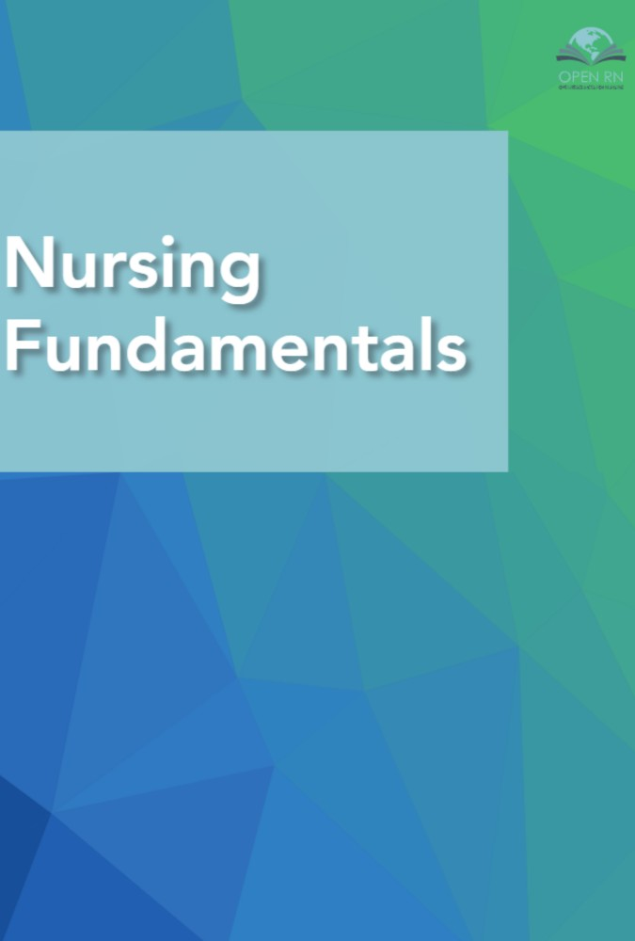

Nursing Fundamentals

Nursing Fundamentals

Open Resources for Nursing (Open RN)

Nursing Fundamentals by Chippewa Valley Technical College is licensed under a Creative Commons Attribution 4.0 International License, except where otherwise noted.

Contents
- Introduction
Open Resources for Nursing (Open RN)
- Preface
- Standards & Conceptual Approach
- Scope of Practice
- 1.1. Scope of Practice Introduction
Open Resources for Nursing (Open RN)
- 1.2 History and Foundation
Open Resources for Nursing (Open RN)
- 1.3 Regulations & Standards
Open Resources for Nursing (Open RN)
- 1.4 Health Care Settings & Team
Open Resources for Nursing (Open RN)
- 1.5 Nursing Education and the NCLEX
Open Resources for Nursing (Open RN)
- 1.6 Legal Considerations & Ethics
Open Resources for Nursing (Open RN)
- 1.7 Professional Organizations
Open Resources for Nursing (Open RN)
- 1.8 Quality and Evidence-Based Practice
Open Resources for Nursing (Open RN)
- 1.9 Learning Activities
Open Resources for Nursing (Open RN)
- I. Glossary
Open Resources for Nursing (Open RN)
- Communication
- 2.1 Communication Introduction
Open Resources for Nursing (Open RN)
- 2.2 Basic Communication Concepts
Open Resources for Nursing (Open RN)
- 2.3 Communicating with Patients
Open Resources for Nursing (Open RN)
- 2.4 Communicating with Health Care Team Members
Open Resources for Nursing (Open RN)
- 2.5 Documentation
Open Resources for Nursing (Open RN)
- 2.6 Putting It All Together
- 2.7 Learning Activities
Open Resources for Nursing (Open RN)
- II Glossary
Open Resources for Nursing (Open RN)
- Diverse Patients
- 3.1 Diverse Patients Introduction
Open Resources for Nursing (Open RN)
- 3.2 Diverse Patients Basic Concepts
Open Resources for Nursing (Open RN)
- 3.3 Patient's Bill of Rights
Open Resources for Nursing (Open RN)
- 3.4 Cultural Competence
Open Resources for Nursing (Open RN)
- 3.5 Health Disparities
Open Resources for Nursing (Open RN)
- 3.6 Culturally Sensitive Care
Open Resources for Nursing (Open RN)
- 3.7 Cultural Assessment
Open Resources for Nursing (Open RN)
- 3.8 Culturally Responsive Care
Open Resources for Nursing (Open RN)
- 3.9 Putting It All Together
- 3.10 Learning Activities
Open Resources for Nursing (Open RN)
- 3.11 Supplementary Videos
Open Resources for Nursing (Open RN)
- III Glossary
Open Resources for Nursing (Open RN)
- Nursing Process
- 4.1 Nursing Process Introduction
Open Resources for Nursing (Open RN)
- 4.2 Basic Concepts
Open Resources for Nursing (Open RN)
- 4.3 Assessment
Open Resources for Nursing (Open RN)
- 4.4 Diagnosis
Open Resources for Nursing (Open RN)
- 4.5 Outcome Identification
Open Resources for Nursing (Open RN)
- 4.6 Planning
Open Resources for Nursing (Open RN)
- 4.7 Implementation of Interventions
Open Resources for Nursing (Open RN)
- 4.8 Evaluation
Open Resources for Nursing (Open RN)
- 4.9 Summary of the Nursing Process
Open Resources for Nursing (Open RN)
- 4.10 Learning Activities
Open Resources for Nursing (Open RN)
- IV Glossary
Open Resources for Nursing (Open RN)
- Safety
- 5.1 Safety Introduction
Open Resources for Nursing (Open RN)
- 5.2 Basic Safety Concepts
Open Resources for Nursing (Open RN)
- 5.3 Safety Strategies
Open Resources for Nursing (Open RN)
- 5.4 Culture of Safety
Open Resources for Nursing (Open RN)
- 5.5 National Patient Safety Goals
Open Resources for Nursing (Open RN)
- 5.6 Preventing Falls
Open Resources for Nursing (Open RN)
- 5.7 Restraints
Open Resources for Nursing (Open RN)
- 5.8 Safety Considerations Across the Life Span
Open Resources for Nursing (Open RN)
- 5.9 Environmental Safety
Open Resources for Nursing (Open RN)
- 5.10 Putting It All Together
- 5.11 Learning Activities
Open Resources for Nursing (Open RN)
- V Glossary
Open Resources for Nursing (Open RN)
- Cognitive Impairments
- 6.1 Cognitive Impairments Introduction
Open Resources for Nursing (Open RN)
- 6.2 Basic Concepts
Open Resources for Nursing (Open RN)
- 6.3 Alzheimer's Disease
Open Resources for Nursing (Open RN)
- 6.4 Applying the Nursing Process
Open Resources for Nursing (Open RN)
- 6.5 Putting It All Together
- 6.6 Learning Activities
Open Resources for Nursing (Open RN)
- VI Glossary
Open Resources for Nursing (Open RN)
- Sensory Impairments
- 7.1 Sensory Impairments Introduction
Open Resources for Nursing (Open RN)
- 7.2 Sensory Impairments Basic Concepts
Open Resources for Nursing (Open RN)
- 7.3 Applying the Nursing Process
Open Resources for Nursing (Open RN)
- 7.4 Putting It All Together
Open Resources for Nursing (Open RN)
- 7.5 Learning Activities
Open Resources for Nursing (Open RN)
- VII Glossary
Open Resources for Nursing (Open RN)
- Oxygenation
- 8.1 Oxygenation Introduction
Open Resources for Nursing (Open RN)
- 8.2 Oxygenation Basic Concepts
Open Resources for Nursing (Open RN)
- 8.3 Applying the Nursing Process
Open Resources for Nursing (Open RN)
- 8.4 Putting It All Together
Open Resources for Nursing (Open RN)
- 8.5 Learning Activities
Open Resources for Nursing (Open RN)
- VIII Glossary
Open Resources for Nursing (Open RN)
- Infection
- 9.1 Infection Introduction
Open Resources for Nursing (Open RN)
- 9.2 Basic Concepts
Open Resources for Nursing (Open RN)
- 9.3 Natural Defenses Against Infection
Open Resources for Nursing (Open RN)
- 9.4 Infection
Open Resources for Nursing (Open RN)
- 9.5 Treating Infection
Open Resources for Nursing (Open RN)
- 9.6 Preventing Infection
Open Resources for Nursing (Open RN)
- 9.7 Applying the Nursing Process
Open Resources for Nursing (Open RN)
- 9.8 Putting It All Together
- 9.9 Learning Activities
Open Resources for Nursing (Open RN)
- IX Glossary
Open Resources for Nursing (Open RN)
- Integumentary
- 10.1 Integumentary Introduction
Open Resources for Nursing (Open RN)
- 10.2 Integumentary Basic Concepts
Open Resources for Nursing (Open RN)
- 10.3 Wounds
Open Resources for Nursing (Open RN)
- 10.4 Pressure Injuries
Open Resources for Nursing (Open RN)
- 10.5 Braden Scale
Open Resources for Nursing (Open RN)
- 10.6 Applying the Nursing Process
Open Resources for Nursing (Open RN)
- 10.7 Putting It All Together
Open Resources for Nursing (Open RN)
- 10.8 Learning Activities
Open Resources for Nursing (Open RN)
- X Glossary
Open Resources for Nursing (Open RN)
- Comfort
- 11.1 Comfort Introduction
Open Resources for Nursing (Open RN)
- 11.2 Comfort Basic Concepts
Open Resources for Nursing (Open RN)
- 11.3 Pain Assessment Methods
Open Resources for Nursing (Open RN)
- 11.4 Pain Management
Open Resources for Nursing (Open RN)
- 11.5 Applying the Nursing Process
Open Resources for Nursing (Open RN)
- 11.6 Putting It All Together
- 11.7 Learning Activities
Open Resources for Nursing (Open RN)
- XI Glossary
Open Resources for Nursing (Open RN)
- Sleep and Rest
- 12.1 Sleep & Rest Introduction
Open Resources for Nursing (Open RN)
- 12.2 Basic Concepts
Open Resources for Nursing (Open RN)
- 12.3 Applying the Nursing Process
Open Resources for Nursing (Open RN)
- 12.4 Putting It All Together
- 12.5 Learning Activities
Open Resources for Nursing (Open RN)
- XII Glossary
Open Resources for Nursing (Open RN)
- Mobility
- 13.1 Mobility Introduction
Open Resources for Nursing (Open RN)
- 13.2 Basic Concepts
Open Resources for Nursing (Open RN)
- 13.3 Applying the Nursing Process
Open Resources for Nursing (Open RN)
- 13.4 Putting It All Together
- 13.5 Learning Activities
Open Resources for Nursing (Open RN)
- XIII Glossary
Open Resources for Nursing (Open RN)
- Nutrition
- 14.1 Nutrition Introduction
Open Resources for Nursing (Open RN)
- 14.2 Nutrition Basic Concepts
Open Resources for Nursing (Open RN)
- 14.3 Applying the Nursing Process
Open Resources for Nursing (Open RN)
- 14.4 Putting It All Together
- 14.5 Learning Activities
Open Resources for Nursing (Open RN)
- XIV Glossary
Open Resources for Nursing (Open RN)
- Fluids and Electrolytes
- 15.1 Fluids and Electrolytes Introduction
Open Resources for Nursing (Open RN)
- 15.2 Basic Fluid and Electrolyte Concepts
Open Resources for Nursing (Open RN)
- 15.3 Intravenous Solutions
Open Resources for Nursing (Open RN)
- 15.4 Electrolytes
Open Resources for Nursing (Open RN)
- 15.5 Acid-Base Balance
Open Resources for Nursing (Open RN)
- 15.6 Applying the Nursing Process
Open Resources for Nursing (Open RN)
- 15.7 Putting It All Together
- 15.8 Learning Activities
Open Resources for Nursing (Open RN)
- XV Glossary
Open Resources for Nursing (Open RN)
- Elimination
- 16.1 Elimination Introduction
Open Resources for Nursing (Open RN)
- 16.2 Basic Concepts
Open Resources for Nursing (Open RN)
- 16.3 Urinary Tract Infection
Open Resources for Nursing (Open RN)
- 16.4 Urinary Incontinence
Open Resources for Nursing (Open RN)
- 16.5 Urinary Retention
Open Resources for Nursing (Open RN)
- 16.6 Constipation
Open Resources for Nursing (Open RN)
- 16.7 Diarrhea
Open Resources for Nursing (Open RN)
- 16.8 Bowel Incontinence
Open Resources for Nursing (Open RN)
- 16.9 Applying the Nursing Process
Open Resources for Nursing (Open RN)
- 16.10 Putting It All Together
- 16.11 Learning Activities
Open Resources for Nursing (Open RN)
- XVI Glossary
Open Resources for Nursing (Open RN)
- Grief and Loss
- 17.1 Grief and Loss Introduction
Open Resources for Nursing (Open RN)
- 17.2 Basic Concepts
Open Resources for Nursing (Open RN)
- 17.3 Applying the Nursing Process to Grief
Open Resources for Nursing (Open RN)
- 17.4 Palliative Care Management
Open Resources for Nursing (Open RN)
- 17.5 Nursing Care During the Final Hours of Life
Open Resources for Nursing (Open RN)
- 17.6 Applying the Nursing Process at End of Life
Open Resources for Nursing (Open RN)
- 17.7 Putting It All Together
- 17.8 Learning Activities
Open Resources for Nursing (Open RN)
- XVII Glossary
Open Resources for Nursing (Open RN)
- Spirituality
- 18.1 Spirituality Introduction
Open Resources for Nursing (Open RN)
- 18.2 Basic Concepts
Open Resources for Nursing (Open RN)
- 18.3 Common Religions and Spiritual Practices
Open Resources for Nursing (Open RN)
- 18.4 Applying the Nursing Process
Open Resources for Nursing (Open RN)
- 18.5 Spiritual Care of Self
Open Resources for Nursing (Open RN)
- 18.6 Putting It All Together
- 18.7 Learning Activities
Open Resources for Nursing (Open RN)
- XVIII Glossary
Open Resources for Nursing (Open RN)
- Care of the Older Adult
- 19.1 Care of the Older Adult Introduction
- 19.2 Basic Concepts
- 19.3 Applying the Nursing Process
- 19.4 Learning Activities
- XIX Glossary
- Answer Key
- Chapter 1 (Scope of Practice)
Open Resources for Nursing (Open RN)
- Chapter 2 (Communication)
Open Resources for Nursing (Open RN)
- Chapter 3 (Diverse Patients)
Open Resources for Nursing (Open RN)
- Chapter 4 (Nursing Process)
Open Resources for Nursing (Open RN)
- Chapter 5 (Safety)
Open Resources for Nursing (Open RN)
- Chapter 6 (Cognitive Impairments)
Open Resources for Nursing (Open RN)
- Chapter 7 (Sensory Impairments)
Open Resources for Nursing (Open RN)
- Chapter 8 (Oxygenation)
Open Resources for Nursing (Open RN)
- Chapter 9 (Infection)
Open Resources for Nursing (Open RN)
- Chapter 10 (Integumentary)
Open Resources for Nursing (Open RN)
- Chapter 11 (Comfort)
Open Resources for Nursing (Open RN)
- Chapter 12 (Sleep and Rest)
Open Resources for Nursing (Open RN)
- Chapter 13 (Mobility)
Open Resources for Nursing (Open RN)
- Chapter 14 (Nutrition)
Open Resources for Nursing (Open RN)
- Chapter 15 (Fluids & Electrolytes)
Open Resources for Nursing (Open RN)
- Chapter 16 (Elimination)
Open Resources for Nursing (Open RN)
- Chapter 17 (Grief and Loss)
Open Resources for Nursing (Open RN)
- Chapter 18 (Spirituality)
Open Resources for Nursing (Open RN)
- Chapter 19 (Care of the Older Adult)
- Appendix A: Sample NANDA-I Diagnoses
Open Resources for Nursing (Open RN)
- Appendix B: Template for Creating a Nursing Care Plan
Open Resources for Nursing (Open RN)
- Appendix C: Sample Abbreviated Care Plan for Scenario C
Open Resources for Nursing (Open RN)

1
Open Resources for Nursing (Open RN)
This Nursing Fundamentals textbook is an open educational resource with CC-BY licensing developed for entry-level nursing students. Content is based on the Wisconsin Technical College System (WTCS) statewide nursing curriculum for the Nursing Fundamentals course (543-101), the 2019 NCLEX-RN Test Plan, the 2020 NCLEX-PN Test Plan, and the Wisconsin Nurse Practice Act.
This book introduces the entry-level nursing student to the scope of nursing practice, various communication techniques, and caring for diverse patients. The nursing process is used as a framework for providing patient care based on the following nursing concepts: safety, oxygenation, comfort, spiritual well-being, grief and loss, sleep and rest, mobility, nutrition, fluid and electrolyte imbalance, and elimination. Care for patients with integumentary disorders and cognitive or sensory impairments is also discussed. Learning activities have been incorporated into each chapter to encourage students to use critical thinking while applying content to patient care situations.
The Open Resources for Nursing (Open RN) project is supported by a $2.5 million grant from the Department of Education. This book is available for free online and can also be downloaded in multiple formats for offline use. The online version is required for interaction with adaptive learning activities included in each chapter. Affordable print versions may also be purchased from XanEdu in college bookstores and on Amazon.
The following video provides a quick overview of how to navigate the online version.
One or more interactive elements has been excluded from this version of the text. You can view them online here: https://wtcs.pressbooks.pub/nursingfundamentals/?p=4#oembed-1

NCSBN. (n.d.).
.

NCSBN. (2019).
.

Wisconsin State Legislature. (2018).
. Board of Nursing.

2

Preface
This Nursing Fundamentals textbook is an open educational resource with a CC-BY 4.0 license developed for entry-level prelicensure nursing students. Content is based on the Wisconsin Technical College System (WTCS) statewide nursing curriculum for the Nursing Fundamentals course (543-101), the 2019 NCLEX-RN Test Plan, the 2020 NCLEX-PN Test Plan, and the Wisconsin Nurse Practice Act.
The project is supported by a $2.5 million Open Resources for Nursing (Open RN) grant from the Department of Education to create five free, open source nursing textbooks. However, this content does not necessarily represent the policy of the Department of Education, and you should not assume endorsement by the federal government.
More information about the Open RN grant can be found at cvtc.edu/OpenRN. The first textbook of the Open RN textbook series, Nursing Pharmacology, received an OE Award for Excellence from OE Global. For more information, visit the 2020 OE Awards for Excellence site.

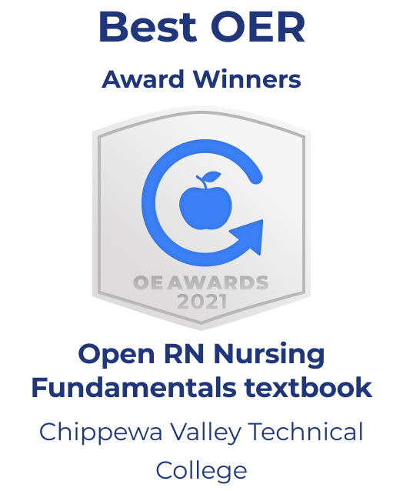

For more information, visit the

Usage Survey and Feedback
We would love to hear if you have integrated some or all of this resource into your course. Please use this short survey to report student usage information every semester that is reported to the Department of Education. Please use this survey to provide constructive feedback or report any errors.

About this Book

Editors
- Kimberly Ernstmeyer, MSN, RN, CNE, CHSE, APNP-BC
- Dr. Elizabeth Christman, DNP, RN, CNE

Graphics Editor
- Nic Ashman, MLIS, Librarian, Chippewa Valley Technical College

Developing Authors
Developing authors remixed existing open educational resources and developed new content based on evidence-based sources:
- Leeann Anthon, MSN, RN, CNE, Madison Area Technical College
- Dr. Lisa Blohm, PhD, RN, Northeast Wisconsin Technical College
- Barbara Brown, MSN, RN, Moraine Park Technical College
- Dr. Elizabeth Christman, DNP, RN, CNE, Chippewa Valley Technical College/Southern New Hampshire University
- Tami Davis, MSN, RN, Chippewa Valley Technical College
- Kim Ernstmeyer, MSN, RN, CNE, CHSE, APNP-BC, Chippewa Valley Technical College
- Dr. Allison Nicol, PhD, RN, CNE, Milwaukee Area Technical College
- Dr. Valerie Palarski, EdD, MSN/ED, RN, Northcentral Technical College
- Lynda Rastall, MSN, RN, CNE, Northeast Wisconsin Technical College
- Julie Sigler, MSN, RN, Chippewa Valley Technical College

Contributors
Contributors assisted in the creation of this textbook:
- Jane Flesher, MST, Proofreader, Chippewa Valley Technical College
- Deanna Hoyord, Paramedic (retired), Human Patient Simulation Technician and Photographer, Chippewa Valley Technical College
- Theresa Meinen, MS, RRT, CHSE, Director of Clinical Education – Respiratory Therapy Program, Chippewa Valley Technical College
- Vince Mussehl, MLIS, Open RN Lead Librarian, Chippewa Valley Technical College
- Joshua Myers, Web Developer, Chippewa Valley Technical College
- Meredith Pomietlo, Retail Design and Marketing Student, UW-Stout
- Lauren Richards, Graphics Designer, Chippewa Valley Technical College
- Celee Schuch, Nursing Student, St. Catherine University
- Christina Sima, MSN, RN, Gateway Community College
- Dominic Slauson, Technology Professional Developer, Chippewa Valley Technical College
- Dr. Jamie Zwicky, EdD, MSN, RN, Moraine Park Technical College

Advisory Committee
The Open RN Advisory Committee consists of industry members and nursing deans and provides input for the Open RN textbooks and virtual reality scenarios:
- Jenny Bauer, MSN, RN, NPD-BC, Mayo Clinic Health System Northwest Wisconsin, Eau Claire, WI
- Gina Bloczynski, MSN, RN, Dean of Nursing, Chippewa Valley Technical College
- Angela Branum, Western Wisconsin Health
- Lisa Cannestra, Eastern Wisconsin Healthcare Alliance
- Travis Christman, MSN, RN, Clinical Director, HSHS Sacred Heart and St. Joseph’s Hospitals
- Sheri Johnson, UW Population Health Institute
- Dr. Vicki Hulback, DNP, RN, Dean of Nursing, Gateway Technical College
- Jenna Julson, MSN, RN, NPD-BC, Nursing Education Specialist, Mayo Clinic Health System Northwest Wisconsin, Eau Claire, WI
- Brian Krogh, MSN, RN, Associate Dean – Health Sciences, Northeast Wisconsin Technical College
- Hugh Leasum, MBA, MSN, RN, Nurse Manager Cardiology/ICU, Marshfield Clinic Health System, Eau Claire, WI
- Pam Maxwell, SSM Health
- Mari Kay-Nobozny, NW Wisconsin Workforce Development Board
- Dr. Amy Olson, DNP, RN, Nursing Education Specialist, Mayo Clinic Health System Northwest Wisconsin, Eau Claire, WI
- Rorey Pritchard, EdS, MEd, MSN, RN-BC, CNOR(E), CNE, Senior RN Clinical Educator, Allevant Solutions, LLC
- Kelly Shafaie, MSN, RN, Associate Dean of Nursing, Moraine Park Technical College
- Dr. Ernise Watson, PhD, RN, Associate Dean of Nursing, Madison Area Technical College
- Sherry Willems, HSHS St. Vincent Hospital

Reviewers
- Emily Adams, MSN, RN, CNE, Arizona Western College
- Ava Alden, Nursing Student, St. Catherine University
- Dr. Caryn Aleo, PhD, RN, CCRN, CEN, CNEcl, NPD-BC, Pasco-Hernando State College
- Dr. Kimberly A. Amos, PhD, MS(N), RN, CNE, Isothermal Community College
- Sara Annunziato, MSN, RN, Rockland Community College
- Megan Baldwin, MSN, RN, CNOR, MercyOne Medical Center, Des Moines, Iowa
- Jenny M. Bauer, MSN, RN, NPD-BC, Mayo Clinic Health System, Northwest Wisconsin
- Lisa Bechard, MSN, RN, Mid-State Technical College
- Ginger Becker, Nursing Student, Portland Community College
- Jolan Berg, MSN, RN, Madison Area Technical College
- Nancy Bonard, MSN, RN-BC, Saint Joseph’s College of Maine
- Valerie J. Bugosh, MSN, RN, CNE, Harrisburg Area Community College
- Dr. Sara I. Cano, PhD, RN, College of Southern Maryland
- Katherine Cart, MSN, MA, RN, Blinn College
- Travis Christman, MSN, RN, HSHS Sacred Heart and St. Joseph’s Hospitals
- Pasang Comfort, Nursing Student, Portland Community College
- Lenore Cortez, MSN, RN-C, Angelo State University
- Dr. Catina Davis, DNP, RN, Tidewater Community College
- Dr. Gerrin Davis, DNP, MA, CRNP, FNP-C, Community College of Baltimore County-Catonsville
- Dr. Andrea Dobogai, DNP, RN, Moraine Park Technical College
- Stacy Svoma Doering, MAEd, RDMS, RVT, Chippewa Valley Technical College
- Jessica Dwork, MSN-ED, RN, Maricopa Community College
- Dr. Maria Motilla Fabro, DNP, APRN-Rx, FNP-BC, Kaua’i Community College
- Dr. Rachael Farrell, EdD, RN, CNE, Howard Community College
- Kathleen Fraley, MSN, RN, St. Clair County Community College
- Kailey Funk, MSN, RN, Madison College
- Kristin Gadzinski, MSN, RN, Lakeshore Technical College
- Amy Gatton, MSN, CNE, Nicolet Area Technical College
- Carla Genovese, MSN, RN-BC, CCRN, Flathead Valley Community College
- Kerry L. Hamm, MSN, RN, Lakeland University
- Melissa Hauge, MSN, RN-BC, Madison College
- Sharon Rhodes Hawkins, MPA, MSN/ed, RN, Sinclair Community College
- Camille Hernandez, MSN, RN, ACNP/FNP-BC, Hawai’i Community College
- Kristine Sioson Holden, MSN, RN, Prince George’s Community College
- Lexa Hosier, Nursing Student, St. Catherine University
- Katherine Howard, MS, RN-BC, CNE, Middlesex County College
- Jenna Julson, MSN, RN, NPD-BC, Mayo Clinic Health System, Northwest Wisconsin
- Lindsay A Kuhlman, BSN, RN, HSHS Sacred Heart Hospital
- Erin Kupkovits, MSN, RN, Madison Area Technical College
- Julie Lepianka, MSN, RN, CNE, Moraine Park Technical College
- Tamella P. Livengood, MSN, FNP-C, Northwestern Michigan College
- Kathy L. Loppnow, MSN, RN, WTCS Health Education Director
- Dawn M. Lyon, MSN, RN, St. Clair County Community College
- Dr. Lydia A. Massias, EdD, MS, RN, Pasco- Hernando State College
- Dr. Jamie Murphy, PhD, RN, State University of New York, Delhi
- Angela Ngo-Bigge, MSN, RN, FNP-C, Grossmont College
- Dr. Tennille O’Connor, DNP, RN, CNE, Pasco- Hernando State College
- Dr. Lilleth D. Okossi, DNP, RN, ACNS-BC, CCRN, Bergen Community College
- Dr. Amy Olson, DNP, RN, Mayo Clinic Health System, Northwest Wisconsin
- Jane Palmieri, MSN, RN, Portland Community College
- Laurie E. Paugel, MSN, RN, Nicolet College
- Dr. Grace Paul, DNP, RN, CNE, Glendale Community College
- Krista Polomis, MSN, RN, Nicolet College
- Mary Pomietlo, MSN, RN, CNE, University of Wisconsin – Eau Claire
- Cassandra Porter, MSN, RN, Lake Land College
- Rorey Pritchard, EdS, MSN, MEd, RN-BC, NPD, CNE, CNOR(E), Allevant Solutions, LLC
- Dr. Regina Prusinski, DNP, APRN, CPNP-AC, BC FNP, Otterbein University
- Jen Renstrom-Dallman, MSN, RN, Chippewa Valley Technical College
- Sharon Rhodes Hawkins, MPA, MSN, RN, Sinclair Community College
- Dr. Debbie Rickeard, DNP, BScN, BA, RN, CNE, CCRN, University of Windsor, Canada
- Dr. Julia E. Robinson, DNP, MSN, APRN, FNP-C, GCNS-BC, Palomar Community College
- Ann K. Rosemeyer, MSN, RN, Chippewa Valley Technical College
- Callie Schlegel, Nursing Student, St. Catherine University
- Celee Schuch, Nursing Students, St. Catherine University
- Chassity Speight-Washburn, MSN, RN, CNE, Stanly Community College
- Dr. Carmen Stephens, DNP, RN, MS, University of Colorado-Anschutz Medical Campus
- Dr. Suzanne H. Tang, DNP, MSN, APRN, FNP-BC, PHN, Rio Hondo College
- Forum Tihara, MSN, RN, Madison Area Technical College
- Jacquelyn R. Titus, MS, RN, Pasco Hernando State College
- Amy L. Tyznik, MSN, RN, Moraine Park Technical College
- Heidi VandenBush, MSN, RN-BC, Northeast Wisconsin Technical College
- Jennie E. Ver Steeg, MA, MS, MLS, Mercy College of Health Sciences
- Dr. Nancy Lynn Whitehead, PhD, APNP, RN, Milwaukee Area Technical College
- Dr. LaDonna Williams, DNP, RN, Lord Fairfax Community College
- Julie Woitalla, MSN, RN, Central Lakes College

Licensing/Terms of Use
This textbook is licensed under a Creative Commons Attribution 4.0 International (CC-BY) license unless otherwise indicated, which means that you are free to:
- SHARE – copy and redistribute the material in any medium or format
- ADAPT – remix, transform, and build upon the material for any purpose, even commercially
The licensor cannot revoke these freedoms as long as you follow the license terms.
- Attribution: You must give appropriate credit, provide a link to the license, and indicate if any changes were made. You may do so in any reasonable manner, but not in any way that suggests the licensor endorses you or your use.
- No Additional Restrictions: You may not apply legal terms or technological measures that legally restrict others from doing anything the license permits.
- Notice: You do not have to comply with the license for elements of the material in the public domain or where your use is permitted by an applicable exception or limitation.
- No Warranties are Given: The license may not give you all of the permissions necessary for your intended use. For example, other rights such as publicity, privacy, or moral rights may limit how you use the material.

Attribution
Some of the content for this textbook was adapted from the following open educational resources. For specific reference information about what was used and/or changed in this adaptation, please refer to the footnotes at the bottom of each page of the book.
- Nursing Pharmacology by Chippewa Valley Technical College is licensed under CC BY 4.0.
- Nursing Skills by Chippewa Valley Technical College is licensed under CC BY 4.0.
- Anatomy and Physiology by Boundless is licensed under CC BY-SA 4.0.
- Anatomy & Physiology by OpenStax is licensed under CC BY 4.0.
- Anatomy and Physiology by Rice University is licensed under CC BY 4.0.
- Clinical Procedures for Safer Care by British Columbia Institute of Technology is licensed under CC BY 4.0.
- The Complete Subjective Health Assessment by Lapum, St-Amant, Hughes, Petrie, Morrell, and Mistry is licensed under CC BY 4.0.
- Concepts of Biology – 1st Canadian Edition by Molnar & Gair is licensed under CC BY 4.0.
- Human Biology by Wakim and Grewal is licensed under CC-BY-NC 4.0.
- Human Relations by LibreTexts is licensed under CC BY-NC-SA.
- Human Development Life Span by Overstreet is licensed under CC BY 4.0.
- Human Nutrition by University of Hawai’i at Mānoa Food Science and Human Nutrition Program is licensed under CC BY 4.0.
- Introduction to Sociology by OpenStax is licensed under CC BY 4.0.
- Microbiology by OpenStax is licensed under CC BY 4.0.
- Nursing Care at the End of Life by Lowey is licensed under CC BY-NC-SA 4.0.
- The Scholarship of Writing in Nursing Education: 1st Canadian Edition by Lapum, St-Amant, Hughes, Tan, Bogdan, Dimaranan, Frantzke, and Savicevic is licensed under CC BY-SA 4.0.
- StatPearls by StatPearls Publishing is licensed under CC BY 4.0.
Content that is not taken from the above OER or public domain should include the following attribution statement:
Ernstmeyer, K., & Christman, E. (Eds.). (2021). Open RN Nursing Fundamentals by Chippewa Valley Technical College is licensed under CC BY 4.0.

NCSBN. (n.d.). 2019 NCLEX-RN test plan.

NCSBN. (2019). NCLEX-PN Examination: Test plan for the national council licensure examination for practical nurses.

Wisconsin State Legislature. (2018). Chapter 6: Standards of practice for registered nurses and licensed practical nurses. Board of Nursing.

3

Standards & Conceptual Approach
The Open RN Nursing Fundamentals textbook is based on several external standards and uses a conceptual approach.

External Standards
American Nurses Association (ANA):
The ANA provides standards for professional nursing practice including nursing standards and a code of ethics for nurses.

  - https://www.nursingworld.org/ana/about-ana/standards/
The National Council Licensure Examination for Registered Nurses: NCLEX-PN and NCLEX-RN Test Plans
The NCLEX-RN and NCLEX-PN test plans are updated every three years to reflect fair, comprehensive, current, and entry-level nursing competency.

  - https://www.ncsbn.org/nclex.htm
The National League of Nursing (NLN): Competencies for Graduates of Nursing Programs
NLN competencies guide nursing curricula to position graduates in a dynamic health care arena with practice that is informed by a body of knowledge and ensures that all members of the public receive safe, quality care.

  - http://www.nln.org/professional-development-programs/competencies-for-nursing-education/nln-competencies-for-graduates-of-nursing-programs
Quality and Safety Education for Nurses (QSEN) Institute: Pre-licensure Competencies
Quality and safety competencies include knowledge, skills, and attitudes to be developed in nursing pre-licensure programs. QSEN competencies include patient-centered care, teamwork and collaboration, evidence-based practice, quality improvement, safety, and informatics.

  - https://qsen.org/competencies/
Wisconsin State Legislature, Administrative Code Chapter N6
The Wisconsin Administrative Code governs the Registered Nursing and Practical Nursing professions in Wisconsin.

  - https://docs.legis.wisconsin.gov/code/admin_code/n/6
Healthy People 2030
Healthy People 2030 envisions a society in which all people can achieve their full potential for health and well-being across the life span. Healthy People provides objectives based on national data and includes social determinants of health.

  - https://health.gov/healthypeople

Conceptual Approach
The Open RN Nursing Fundamentals textbook incorporates the following concepts across all chapters:
- Holism. Florence Nightingale taught nurses to focus on the principles of holism, including wellness and the interrelationship of human beings and their environment. This textbook encourages the application of holism by assessing the impact of developmental, emotional, cultural, religious, and spiritual influences on a patient’s health status.
- Evidence-Based Practice (EBP). Textbook content is based on current, evidence-based practices that are referenced by footnotes. To promote digital literacy, hyperlinks are provided to credible, free online resources that supplement content. The Open RN textbooks will be updated as new EBP is established and with the release of updated NCLEX Test Plans every three years.
- Cultural Competency. Nurses have an ethical and moral obligation to provide culturally competent care to the patients they serve based on the ANA Code of Ethics. Cultural considerations are included throughout this textbook.
- Care Across the Life Span. Developmental stages are addressed regarding patient assessments and procedures.
- Health Promotion. Focused interview questions and patient education topics are included to promote patient well-being and encourage self-care behaviors.
- Scope of Practice. Assessment techniques are included that have been identified as frequently performed by entry-level nurse generalists.,,,
- Patient Safety. Expected and unexpected findings on assessment are highlighted in tables to promote patient safety by encouraging notification of health care providers when changes in condition occur.
- Clear and Inclusive Language. Content is written using clear language preferred by entry-level pre-licensure nursing students to enhance understanding of complex concepts. “They” is used as a singular pronoun to refer to a person whose gender is unknown or irrelevant to the context of the usage, as endorsed by APA style. It is inclusive of all people and helps writers avoid making assumptions about gender.
- Open Source Images and Fair Use. Images are included to promote visual learning. Students and faculty can reuse open source images by following the terms of their associated Creative Commons licensing. Some images are included based on Fair Use as described in the “Code of Best Practices for Fair Use and Fair Dealing in Open Education” presented at the OpenEd20 conference. Refer to the footnotes of images for source and licensing information throughout the text.
- Open Pedagogy. Students are encouraged to contribute to the Open RN textbooks in meaningful ways. In this textbook, students assisted in reviewing content for clarity for an entry-level learner and also assisted in creating open source images.

Supplementary Material Provided
Several supplementary resources are provided with this textbook.
- Supplementary, free videos to promote student understanding of concepts and procedures
- Sample documentation for assessments and procedures
- Online learning activities with formative feedback
- Critical thinking questions that encourage application of content to patient scenarios
- Free downloadable versions for offline use
An affordable print version of this textbook is published by XanEdu and is available on Amazon and in college bookstores. It has been reported that over 65% of students prefer a print version of their textbooks.

American Nurses Association. (2015).
. American Nurses Association.

Anderson, B., Nix, E., Norman, B., & McPike, H. D. (2014). An evidence based approach to undergraduate physical assessment practicum course development.
(3), 242–246.

Giddens, J., & Eddy, L. (2009). A survey of physical examination skills taught in undergraduate nursing programs: Are we teaching too much?
(1), 24–29.

Giddens, J. (2007). A survey of physical assessment techniques performed by RNs: Lessons for nursing education.
(2), 83–87.

Morrell, S., Ralph, J., Giannotti, N., Dayus, D., Dennison, S., & Bornais, J.(2019). Physical assessment skills in nursing curricula: A scoping review protocol.
(6), 1086-1091.
.

Verkuyl, M., Lapum, J., St-Amant, O., Bregstein, J., & Hughes, M. (2020). Healthcare students’ use of an e-textbook open educational resource on vital sign measurement: A qualitative study.

American Psychological Association (2021).

by Steel Wagstaff is licensed under

Verkuyl, M., Lapum, J., St-Amant, O., Bregstein, J., & Hughes, M. (2020). Healthcare students’ use of an e-textbook open educational resource on vital sign measurement: A qualitative study.

I

Scope of Practice

1.1. Scope of Practice Introduction
Open Resources for Nursing (Open RN)

Learning Objectives
- Discuss nursing scope of practice and standards of care
- Compare various settings in which nurses work
- Describe contributions of interprofessional health care team members
- Describe levels of nursing education and the NCLEX
- Discuss basic legal considerations and ethics
- Outline professional nursing organizations
- Examine quality and evidence-based practice in nursing
You are probably wondering, “What is scope of practice? What does it mean for me and my nursing practice?” Scope of practice is defined as services that a trained health professional is deemed competent to perform and permitted to undertake according to the terms of their professional nursing license. Nursing scope of practice provides a framework and structured guidance for activities one can perform based on their nursing license. As a nurse and a nursing student, is always important to consider: Just because your employer asks you to do a task…can you perform this task according to your scope of practice – or are you putting your nursing license at risk?
Nurses must also follow legal standards in when providing nursing care. Standards are set by several organizations, including the American Nurses Association (ANA), your state’s Nurse Practice Act, agency policies and procedures, and federal regulators. These standards assure safe, competent care is provided to the public.
This chapter will provide an overview of basic concepts related to nursing scope of practice and standards of care.

American Nurses Association. (n.d.).

1.2 History and Foundation
Open Resources for Nursing (Open RN)

Brief History of Nursing
Before discussing scope and standards of nursing care, it is helpful to briefly review a history of the nursing profession. Florence Nightingale is considered to be the founder of modern nursing practice. In 1860 she established the first nursing school in the world. By establishing this school of nursing, Nightingale promoted the concept of nurses as a professional, educated workforce of caregivers for the sick. See Figure 1.1 for a portrait of Florence Nightingale. Florence Nightingale’s contributions to health care started during the Crimean War in 1854. Her team discovered that poor health care for wounded soldiers was being delivered by overworked medical staff in a dirty environment. Florence recorded the mortality rate in the hospital and created statistical models that demonstrated that out of every 1,000 injured soldiers, 600 were dying because of preventable communicable and infectious diseases. Florence’s nursing interventions were simple; she focused on providing a clean environment, clean water, and good nutrition to promote healing, such as providing fruit as part of the care for the wounded soldiers. With these simple actions, the mortality rate of the soldiers decreased from 60% to 2.2%. In 1859 Nightingale wrote a book titled Notes on Nursing that served as the cornerstone of the Nightingale School of Nursing curriculum. Nightingale believed in the importance of placing a patient in a environment that promoted healing where they could recover from disease. She promoted this knowledge as distinct from medical knowledge. Her emphasis on the value of the environment formed many of the foundational principles that we still use in creating a healing health care setting today. She also insisted on the importance of building trusting relationships with patients and believed in the therapeutic healing that resulted from nurses’ presence with patients. She promoted the concept of confidentiality, stating a nurse “should never answer questions about her sick except to those who have a right to ask them.”These nursing concepts formed the foundation of nursing practice as we know it today.

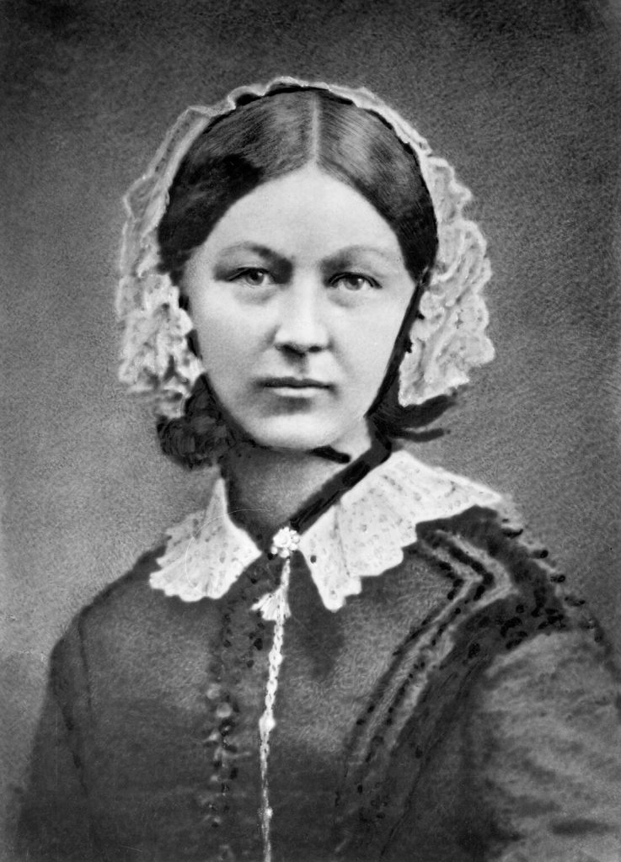

Modern nursing has reinvented itself a number of times as health care has advanced and changed over the past 160 years. With more than four million members, the nursing profession represents the largest segment of the United States’ health care workforce. Nursing practice covers a broad continuum, including health promotion, disease prevention, coordination of care, and palliative care when cure is not possible. Nurses directly affect patient care and provide the majority of patient assessments, evaluations, and care in hospitals, nursing homes, clinics, schools, workplaces, and ambulatory settings. They are at the front lines in ensuring that patient care is delivered safely, effectively, and compassionately. Additionally, nurses attend to patients and their families in a holistic way that often goes beyond physical health needs and recognize social, mental, emotional, and spiritual needs.

American Nurses Association (ANA)
The American Nurses Association (ANA) is a national, professional nursing organization that was established in 1896. The ANA represents the interests of nurses in all 50 states of America while also promoting improved health care for everyone. The mission of the ANA is to “lead the profession to shape the future of nursing and health care.” The ANA states that it exists to advance the nursing profession by doing the following:
- Fostering high standards of nursing practice
- Promoting a safe and ethical work environment
- Bolstering the health and wellness of nurses
- Advocating on health care issues that affect nurses and the public
The ANA sets many standard of care for professional nurses that will be discussed in the next section.
Read more information about the American Nurses Association
View the Discover the American Nurses Association video.

Karimi, H., & Masoudi Alavi, N. (2015). Florence Nightingale: The mother of nursing.
(2), e29475.

“
” by Henry Hering (1814-1893) is in the

Karimi, H., & Masoudi Alavi, N. (2015). Florence Nightingale: The mother of nursing.
(2), e29475.
.

Institute of Medicine (US) Committee on the Robert Wood Johnson Foundation Initiative on the Future of Nursing, at the Institute of Medicine. (2011).
National Academies Press.

American Nurses Association. (n.d.).

American Nurses Association. (n.d.).
.

American Nurses Association. (2010, May 14).
. [Video]. YouTube. All rights reserved.

1.3 Regulations & Standards
Open Resources for Nursing (Open RN)
Standards for nursing care are set by several organizations, including the American Nurses Association (ANA), your state’s Nurse Practice Act, agency policies and procedures, federal regulators, and other professional nursing organizations. These standards assure safe, competent care is provided to the public.

ANA Scope and Standards of Practice
The American Nurses Association (ANA) publishes two resources that set standards and guide professional nursing practice in the United States: The Code of Ethics for Nurses and Nursing: Scope and Standards of Practice. The Code of Ethics for Nurses establishes an ethical framework for nursing practice across all roles, levels, and settings. It is discussed in greater detail in the “Legal Considerations and Ethics” subsection of this chapter. The Nursing: Scope and Standards of Practice describes a professional nurse’s scope of practice and defines the who, what, where, when, why, and how of nursing. It also sets 18 standards of professional practice that all registered nurses are expected to perform competently.
The “who” of nursing practice are the nurses who have been educated, titled, and maintain active licensure to practice nursing. The “what” of nursingis the recently revised definition of nursing: “Nursing integrates the art and science of caring and focuses on the protection, promotion, and optimization of health and human functioning; prevention of illness and injury; facilitation of healing; and alleviation of suffering through compassionate presence. Nursing is the diagnosis and treatment of human responses and advocacy in the care of individuals, families, groups, communities, and populations in recognition of the connection of all humanity.” Simply put, nurses treat human responses to health problems and life processes and advocate for the care of others.
Nursing practice occurs “when” there is a need for nursing knowledge, wisdom, caring, leadership, practice, or education, anytime, anywhere. Nursing practice occurs in any environment “where” there is a health care consumer in need of care, information, or advocacy. The “why” of nursing practice is described as nursing’s response to the changing needs of society to achieve positive health care consumer outcomes in keeping with nursing’s social contract and obligation to society. The “how” of nursing practice is defined as the ways, means, methods, and manners that nurses use to practice professionally. The “how” of nursing is further defined by the standards of practice set by the ANA. There are two sets of standards, the Standards of Professional Nursing Practice and the Standards of Professional Performance.
The Standards of Professional Nursing Practice are “authoritative statements of the actions and behaviors that all registered nurses, regardless of role, population, specialty, and setting, are expected to perform competently.”These standards define a competent level of nursing practice based on the critical thinking model known as the nursing process. The nursing process includes the components of assessment, diagnosis, outcomes identification, planning, implementation, and evaluation.Each of these standards is further discussed in the “Nursing Process” chapter of this book.
The Standards of Professional Performance are 12 additional standards that describe a nurse’s professional behavior, including activities related to ethics, advocacy, respectful and equitable practice, communication, collaboration, leadership, education, scholarly inquiry, quality of practice, professional practice evaluation, resource stewardship, and environmental health. All registered nurses are expected to engage in these professional role activities based on their level of education, position, and role. Registered nurses are accountable for their professional behaviors to themselves, health care consumers, peers, and ultimately to society. The 2021 Standards of Professional Performance are as follows:
- Ethics. The registered nurse integrates ethics in all aspects of practice.
- Advocacy. The registered nurse demonstrates advocacy in all roles and settings.
- Respectful and Equitable Practice. The registered nurse practices with cultural humility and inclusiveness.
- Communication. The registered nurse communicates effectively in all areas of professional practice.
- Collaboration. The registered nurse collaborates with the health care consumer and other key stakeholders.
- Leadership. The registered nurse leads within the profession and practice setting.
- Education. The registered nurse seeks knowledge and competence that reflects current nursing practice and promotes futuristic thinking.
- Scholarly Inquiry. The registered nurse integrates scholarship, evidence, and research findings into practice.
- Quality of Practice. The registered nurse contributes to quality nursing practice.
- Professional Practice Evaluation. The registered nurse evaluates one’s own and others’ nursing practice.
- Resource Stewardship. The registered nurse utilizes appropriate resources to plan, provide, and sustain evidence-based nursing services that are safe, effective, financially responsible, and judiciously used.
- Environmental Health. The registered nurse practices in a manner that advances environmental safety and health.
Years ago, nurses were required to recite the Nightingale pledge to publicly confirm their commitment to maintain the profession’s high ethical and moral values: “I will do all in my power to maintain and elevate the standard of my profession and will hold in confidence all personal matters committed to my keeping and family affairs coming to my knowledge in the practice of my calling, with loyalty will I endeavor to aid the physician in his work, and devote myself to the welfare of those committed to my care.” Although some of the words are outdated, the meaning is clear: Nursing is a calling, not just a job; to answer that call, you must be dedicated to serve your community according to the ANA standards of care and code of ethics.

Nurse Practice Act
In addition to the professional standards of practice and professional performance set by the American Nurses Association, nurses must legally follow regulations set by the Nurse Practice Act and enforced by the Board of Nursingin the state where they are employed. The Board of Nursing is the state-specific licensing and regulatory body that sets standards for safe nursing care and issues nursing licenses to qualified candidates, based on the Nurse Practice Act enacted by that state’s legislature. The Nurse Practice Act establishes regulations for nursing practice within that state and defines the scope of nursing practice. If nurses do not follow the standards and scope of practice set forth by the Nurse Practice Act, they can have their nursing license revoked by the Board of Nursing.
To read more about the the Wisconsin Board of Nursing, Standards of Practice, and Rules of Conduct, use the hyperlinked PDFs provided below.
Read more details about the Wisconsin Administrative Code and the Board of Nursing.
Read about Wisconsin Standards of Practice for Nurses in Chapter N 6.
Read about Wisconsin Rules of Conduct in Chapter N 7.
Nursing students must understand their scope of practice outlined in their state’s Nurse Practice Act. Nursing students are legally accountable for the quality of care they provide to patients just as nurses are accountable. Students are expected to recognize the limits of their knowledge and experience and appropriately alert individuals in authority regarding situations that are beyond their competency. A violation of the standards of practice constitutes unprofessional conduct and can result in the Board of Nursing denying a license to a nursing graduate.

Employer Policies, Procedures, and Protocols
In addition to professional nursing standards set by the American Nurses Association and the state Nurse Practice Act where they work, nurses and nursing students must also practice according to agency policies, procedures, and protocols. For example, hospitals often set a policy that requires a thorough skin assessment must be completed and documented daily on every patient. If a nurse did not follow this policy and a patient developed a pressure injury, the nurse could be held liable. In addition, every agency has their own set of procedures and protocols that a nurse and nursing student must follow. For example, each agency has specific procedural steps for performing nursing skills, such as inserting urinary catheters. A protocol is defined by the Wisconsin Nurse Practice Act as a “precise and detailed written plan for a regimen of therapy.” For example, agencies typically have a hypoglycemia protocol that nurses automatically implement when a patient’s blood sugar falls below a specific number. The hypoglycemia protocol includes actions such as providing orange juice and rechecking the blood sugar. These agency-specific policies, procedures, and protocols supersede the information taught in nursing school, and nurses and nursing students can be held legally liable if they don’t follow them. Therefore, it is vital for nurses and nursing students to always review and follow current agency-specific procedures, policies, and protocols when providing patient care.
Nurses and nursing students must continue to follow their scope of practice as defined by the Nurse Practice Act in the state they are practicing when following agency policies, procedures, and protocols. Situations have occurred when a nurse or nursing student was asked by an agency to do something outside their defined scope of practice that impaired their nursing license. It is always up to you to protect your nursing license and follow the state’s Nurse Practice Act when providing patient care.

Federal Regulations
In addition to nursing scope of practice and standards being defined by the American Nurses Association, state Nurse Practice Acts, and employer policies, procedures, and protocols, nursing practice is also influenced by federal regulations enacted by agencies such as the Joint Commission and the Centers for Medicare and Medicaid.

The Joint Commission
The Joint Commission is a national organization that accredits and certifies over 20,000 health care organizations in the United States. The mission of The Joint Commission (TJC) is to continuously improve health care for the public by inspiring health care organizations to excel in providing safe and effective care of the highest quality and value. The Joint Commission sets standards for providing safe, high-quality health care.

National Patient Safety Goals
The Joint Commission establishes annual National Patient Safety Goals for various types of agencies based on data regarding current national safety concerns. For example, National Patient Safety Goals for hospitals include the following:
- Identify Patients Correctly
- Improve Staff Communication
- Use Medicines Safely
- Use Alarms Safely
- Prevent Infection
- Identify Patient Safety Risks
- Prevent Mistakes in Surgery
Nurses, nursing students, and other staff members are expected to incorporate actions related to these safety goals into their daily patient care. For example, SBAR (Situation, Background, Assessment, and Recommendation) handoff reporting techniques, bar code scanning equipment, and perioperative team “time-outs” prior to surgery are examples of actions incorporated at agencies based on National Patient Safety Goals. Nursing programs also use National Patient Safety Goals to guide their curriculum and clinical practice expectations. National Patient Safety Goals are further discussed in the “Safety” chapter of this book.
Use the hyperlinks provided below to read more about The Joint Commission and National Patient Safety Goals.
The Joint Commission
The Joint Commissions’ National Patient Safety Goals

Joint Commission Center for Transforming Healthcare
The Joint Commission Center for Transforming Healthcare was developed in 2008 to help agencies develop effective solutions for critical safety problems with a goal to ultimately achieve zero harm to patients. Some of the projects the Center has developed include improved hand hygiene, effective handoff communications, and safe and effective use of insulin. The Center has also been instrumental in creating a focus on a safety culture in health care organizations. A safety culture empowers nurses, nursing students, and other staff members to speak up about their concerns about patient risks and to report errors and near misses, all of which drive improvement in patient care and reduce the incidences of patient harm. Many health care agencies have implemented a safety culture in their workplace and successfully reduced incidences of patient harm. An example of a safety culture action is a nurse or nursing student creating an incident report when an error occurs when administering medication. The incident report is used by the agency to investigate system factors that contribute to errors. To read more about creating a safety culture, use the hyperlink provided below.
Read more about Creating a Safety Culture.

Centers for Medicare & Medicaid Services
The Centers for Medicare & Medicaid Services (CMS) is another federal agency that establishes regulations that affect nursing care. CMS is a part of the U.S. Department of Health and Human Services (HHS) that administers the Medicare program and works in partnership with state governments to administer Medicaid. The CMS establishes and enforces regulations to protect patient safety in hospitals that receive Medicare and Medicaid funding. For example, one CMS regulation states that a hospital’s policies and procedures must require confirmation of specific information before medication is administered to patients. This CMS regulation is often referred to as “checking the rights of medication administration.” You can read more information about checking the rights of medication administration in the “Administration of Enteral Medications” chapter of the Open RN Nursing Skills textbook.
CMS also enforces quality standards in health care organizations that receive Medicare and Medicaid funding. These organizations are reimbursed based on the quality of their patient outcomes. For example, organizations with high rates of healthcare-associated infections (HAI) receive less reimbursement for services they provide. As a result, many agencies have reexamined their policies, procedures, and protocols to promote optimal patient outcomes and maximum reimbursement.
Now that we have discussed various agencies that affect a nurse’s scope and standards of practice, let’s review various types of health care settings where nurses work and members of the health care team.

American Nurses Association. (2021).
(4th ed.). American Nurses Association

American Nurses Association. (2021).
(4th ed.). American Nurses Association

American Nurses Association. (2021).
(4th ed.). American Nurses Association

American Nurses Association. (2021).
(4th ed.). American Nurses Association

American Nurses Association. (2021).
(4th ed.). American Nurses Association.

American Nurses Association. (2021).
(4th ed.). American Nurses Association.

American Nurses Association. (2021).
(4th ed.). American Nurses Association.

Bostain, L. (2020, June 25). Nursing professionalism begins with you.
.

Wisconsin Administrative Code. (2018).

The Joint Commission. (n.d.).
/

The Joint Commission. (n.d.).
.

Joint Commission Center for Transforming Healthcare. (n.d.).
.

This work is a derivative of
by
and is licensed under

1.4 Health Care Settings & Team
Open Resources for Nursing (Open RN)

Health Care Settings
There are several levels of health care including primary, secondary, and tertiary care. Each of these levels focuses on different aspects of health care and is typically provided in different settings.

Primary Care
Primary care promotes wellness and prevents disease. This care includes health promotion, education, protection (such as immunizations), early disease screening, and environmental considerations. Settings providing this type of health care include physician offices, public health clinics, school nursing, and community health nursing.

Secondary care
Secondary care occurs when a person has contracted an illness or injury and requires medical care. Secondary care is often referred to as acute care. Secondary care can range from uncomplicated care to repair a small laceration or treat a strep throat infection to more complicated emergent care such as treating a head injury sustained in an automobile accident. Whatever the problem, the patient needs medical and nursing attention to return to a state of health and wellness. Secondary care is provided in settings such as physician offices, clinics, urgent care facilities, or hospitals. Specialized units include areas such as burn care, neurosurgery, cardiac surgery, and transplant services.

Tertiary Care
Tertiary care addresses the long-term effects from chronic illnesses or conditions with the purpose to restore a patient’s maximum physical and mental function. The goal of tertiary care is to achieve the highest level of functioning possible while managing the chronic illness. For example, a patient who falls and fractures their hip will need secondary care to set the broken bones, but may need tertiary care to regain their strength and ability to walk even after the bones have healed. Patients with incurable diseases, such as dementia, may need specialized tertiary care to provide support they need for daily functioning. Tertiary care settings include rehabilitation units, assisted living facilities, adult day care, skilled nursing units, home care, and hospice centers.

Health Care Team
No matter the setting, quality health care requires a team of health care professionals collaboratively working together to deliver holistic, individualized care. Nursing students must be aware of the roles and contributions of various health care team members. The health care team consists of health care providers, nurses (licensed practical nurses, registered nurses, and advanced registered nurses), unlicensed assistive personnel, and a variety of interprofessional team members.

Health Care Providers
The Wisconsin Nurse Practice Act defines a provider as, “A physician, podiatrist, dentist, optometrist, or advanced practice nurse.” Providers are responsible for ordering diagnostic tests such as blood work and X-rays, diagnosing a patient’s medical condition, developing a medical treatment plan, and prescribing medications. In a hospital setting, the medical treatment plan developed by a provider is communicated in the “History and Physical” component of the patient’s medical record with associated prescriptions (otherwise known as “orders”). Prescriptions or “orders” include diagnostic and laboratory tests, medications, and general parameters regarding the care that each patient is to receive. Nurses should respectfully clarify prescriptions they have questions or concerns about to ensure safe patient care. Providers typically visit hospitalized patients daily in what is referred to as “rounds.” It is helpful for nurses and nursing students to attend provider rounds for their assigned patients to be aware of and provide input regarding the current medical treatment plan, seek clarification, or ask questions. This helps to ensure that the provider, nurse, and patient have a clear understanding of the goals of care and minimize the need for follow-up phone calls.

Nurses
There are three levels of nurses as defined by each state’s Nurse Practice Act: Licensed Practical Nurse/Vocational Nurse (LPN/LVN), Registered Nurse (RN), and Advanced Practice Nurse (APRN).

Licensed Practical/Vocational Nurses
The NCSBN defines a licensed practical nurse (LPN) as, “An individual who has completed a state-approved practical or vocational nursing program, passed the NCLEX-PN examination, and is licensed by a state board of nursing to provide patient care.” In some states, the term licensed vocational nurse (LVN) is used. LPN/LVNs typically work under the supervision of a registered nurse, advanced practice registered nurse, or physician. LPNs provide “basic nursing care” and work with stable and/or chronically ill populations. Basic nursing care is defined by the Wisconsin Nurse Practice Act as “care that can be performed following a defined nursing procedure with minimal modification in which the responses of the patient to the nursing care are predictable.” LPN/LVNs typically collect patient assessment information, administer medications, and perform nursing procedures according to their scope of practice in that state. The Open RN Nursing Skills textbook discusses the skills and procedures that LPNs frequently perform in Wisconsin. See the following box for additional details about the scope of practice of the Licensed Practical Nurse in Wisconsin.
Scope of Practice for Licensed Practical Nurses in Wisconsin
The Wisconsin Nurse Practice Act defines the scope of practice for Licensed Practical Nurses as the following: “In the performance of acts in basic patient situations, the LPN shall, under the general supervision of an RN or the direction of a provider:
(a) Accept only patient care assignments which the LPN is competent to perform.
(b) Provide basic nursing care.
(c) Record nursing care given and report to the appropriate person changes in the condition of a patient.
(d) Consult with a provider in cases where an LPN knows or should know a delegated act may harm a patient.
(e) Perform the following other acts when applicable:
- Assist with the collection of data.
- Assist with the development and revision of a nursing care plan.
- Reinforce the teaching provided by an RN provider and provide basic health care instruction.
- Participate with other health team members in meeting basic patient needs.”

Registered Nurses
The NCSBN defines a Registered Nurse as “An individual who has graduated from a state-approved school of nursing, passed the NCLEX-RN examination and is licensed by a state board of nursing to provide patient care.” Registered Nurses (RNs) use the nursing process as a critical thinking model as they make decisions and use clinical judgment regarding patient care. The nursing process is discussed in more detail in the “Nursing Process” chapter of this book. RNs may be delegated tasks from providers or may delegate tasks to LPNs and UAPs with supervision. See the following box for additional details about the scope of practice for Registered Nurses in the state of Wisconsin.
Scope of Practice for Registered Nurses in Wisconsin
(1) GENERAL NURSING PROCEDURES. An RN shall utilize the nursing process in the execution of general nursing procedures in the maintenance of health, prevention of illness or care of the ill. The nursing process consists of the steps of assessment, planning, intervention, and evaluation. This standard is met through performance of each of the following steps of the nursing process:
(a) Assessment. Assessment is the systematic and continual collection and analysis of data about the health status of a patient culminating in the formulation of a nursing diagnosis.
(b) Planning. Planning is developing a nursing plan of care for a patient, which includes goals and priorities derived from the nursing diagnosis.
(c) Intervention. Intervention is the nursing action to implement the plan of care by directly administering care or by directing and supervising nursing acts delegated to LPNs or less skilled assistants.
(d) Evaluation. Evaluation is the determination of a patient’s progress or lack of progress toward goal achievement, which may lead to modification of the nursing diagnosis.
(2) PERFORMANCE OF DELEGATED ACTS. In the performance of delegated acts, an RN shall do all of the following:
(a) Accept only those delegated acts for which there are protocols or written or verbal orders.
(b) Accept only those delegated acts for which the RN is competent to perform based on his or her nursing education, training or experience.
(c) Consult with a provider in cases where the RN knows or should know a delegated act may harm a patient.
(d) Perform delegated acts under the general supervision or direction of provider.
(3) SUPERVISION AND DIRECTION OF DELEGATED ACTS. In the supervision and direction of delegated acts, an RN shall do all of the following:
(a) Delegate tasks commensurate with educational preparation and demonstrated abilities of the person supervised.
(b) Provide direction and assistance to those supervised.
(c) Observe and monitor the activities of those supervised.
(d) Evaluate the effectiveness of acts performed under supervision.

Advanced Practice Nurses
Advanced Practice Nurses (APRN) are defined by the NCSBN as an RN who has a graduate degree and advanced knowledge. There are four categories of Advanced Practice Nurses: certified nurse-midwife (CNM), clinical nurse specialist (CNS), certified nurse practitioner (CNP), and certified registered nurse anesthetist (CRNA). APRNs can diagnose illnesses and prescribe treatments and medications. Additional information about advanced nursing degrees and roles is provided in the box below.
Advanced Practice Nursing Roles
Nurse Practitioners: Nurse practitioners (NPs) work in a variety of settings and complete physical examinations, diagnose and treat common acute illness and manage chronic illness, order laboratory and diagnostic tests, prescribe medications and other therapies, provide health teaching and supportive counseling with an emphasis on prevention of illness and health maintenance, and refer patients to other health professionals and specialists as needed. In many states, NPs can function independently and manage their own clinics, whereas in other states physician supervision is required. NP certifications include, but are not limited to, Family Practice, Adult-Gerontology Primary Care and Acute Care, and Psychiatric/Mental Health.
To read more about NP certification, visit Nursing World’s Our Certifications web page.
Clinical Nurse Specialists: Clinical Nurse Specialists (CNS) practice in a variety of health care environments and participate in mentoring other nurses, case management, research, designing and conducting quality improvement programs, and serving as educators and consultants. Specialty areas include, but are not limited to, Adult/Gerontology, Pediatrics, and Neonatal.
To read more about CNS certification, visit NACNS’s What is a CNS? web page.
Certified Registered Nurse Anesthetists: Certified Registered Nurse Anesthetists (CRNAs) administer anesthesia and related care before, during, and after surgical, therapeutic, diagnostic, and obstetrical procedures, as well as provide airway management during medical emergencies. CRNAs deliver more than 65 percent of all anesthetics to patients in the United States. Practice settings include operating rooms, dental offices, and outpatient surgical centers.
To read more about CRNA certification, visit NBCRNA’s website.
Certified Nurse Midwives: Certified Nurse Midwives provide gynecological exams, family planning advice, prenatal care, management of low-risk labor and delivery, and neonatal care. Practice settings include hospitals, birthing centers, community clinics, and patient homes.
To read more about CNM certification, visit AMCB Midwife’s website.

Unlicensed Assistive Personnel
Unlicensed Assistive Personnel(UAP) are defined by the NCSBN as, “Any unlicensed person, regardless of title, who performs tasks delegated by a nurse. This includes certified nursing aides/assistants (CNAs), patient care assistants (PCAs), patient care technicians (PCTs), state tested nursing assistants (STNAs), nursing assistants-registered (NA/Rs), or certified medication aides/assistants (MA-Cs). Certification of UAPs varies between jurisdictions.”
CNAs, PCAs, and PCTs in Wisconsin generally work in hospitals and long-term care facilities and assist patients with daily tasks such as bathing, dressing, feeding, and toileting. They may also collect patient information such as vital signs, weight, and input/output as delegated by the nurse. The RN remains accountable that delegated tasks have been completed and documented by the UAP.

Interprofessional Team Members
Nurses, as the coordinator of a patient’s care, continuously review the plan of care to ensure all contributions of the multidisciplinary team are moving the patient toward expected outcomes and goals. The roles and contributions of interprofessional health care team members are further described in the following box.
Interprofessional Team Member Roles
Dieticians: Dieticians assess, plan, implement, and evaluate interventions including those relating to dietary needs of those patients who need regular or therapeutic diets. They also provide dietary education and work with other members of the health care team when a client has dietary needs secondary to physical disorders such as dysphagia.
Occupational Therapists (OT): Occupational therapists assess, plan, implement, and evaluate interventions, including those that facilitate the patient’s ability to achieve their highest possible level of independence in their activities of daily living such as bathing, grooming, eating, and dressing. They also provide patients adaptive devices such as long shoe horns so the patient can put their shoes on, sock pulls so they can independently pull on socks, adaptive silverware to facilitate independent eating, grabbers so the patient can pick items up from the floor, and special devices to manipulate buttoning so the person can dress and button their clothing independently. Occupational therapists also assess the home for safety and the need for assistive devices when the patient is discharged home. They may recommend modifications to the home environment such as ramps, grab rails, and handrails to ensure safety and independence. Like physical therapists, occupational therapists practice in all health care environments including the home, hospital, and rehabilitation centers.
Pharmacists: Pharmacists ensure the safe prescribing and dispensing of medication and are a vital resource for nurses with questions or concerns about medications they are administering to patients. Pharmacists ensure that patients not only get the correct medication and dosing, but also have the guidance they need to use the medication safely and effectively.
Physical Therapists (PT): Physical therapists are licensed health care professionals who assess, plan, implement, and evaluate interventions including those related to the patient’s functional abilities in terms of their strength, mobility, balance, gait, coordination, and joint range of motion. They supervise prescribed exercise activities according to a patient’s condition and also provide and teach patients how to use assistive aids like walkers and canes and exercise regimens. Physical therapists practice in all health care environments including the home, hospital, and rehabilitation centers.
Podiatrists: Podiatrists provide care and services to patients who have foot problems. They often work with diabetic patients to clip toenails and provide foot care to prevent complications.
Prosthetists: Prosthetists design, fit, and supply the patient with an artificial body part such as a leg or arm prosthesis. They adjust prosthesis to ensure proper fit, patient comfort, and functioning.
Psychologists and Psychiatrists: Psychologists and psychiatrists provide mental health and psychiatric services to patients with mental health disorders and provide psychological support to family members and significant others as indicated.
Respiratory Therapists: Respiratory therapists treat respiratory-related conditions in patients. Their specialized respiratory care includes managing oxygen therapy; drawing arterial blood gases; managing patients on specialized oxygenation devices such as mechanical ventilators, CPAP, and Bi-PAP machines; administering respiratory medications like inhalers and nebulizers; intubating patients; assisting with bronchoscopy and other respiratory-related diagnostic tests; performing pulmonary hygiene measures like chest physiotherapy; and serving an integral role during cardiac and respiratory arrests.
Social Workers: Social workers counsel patients and provide psychological support, help set up community resources according to patients’ financial needs, and serve as part of the team that ensures continuity of care after the person is discharged.
Speech Therapists: Speech therapists assess, diagnose, and treat communication and swallowing disorders. For example, speech therapists help patients with a disorder called expressive aphasia. They also assist patients with using word boards and other electronic devices to facilitate communication. They assess patients with swallowing disorders called dysphagia and treat them in collaboration with other members of the health care team including nurses, dieticians, and health care providers.
Ancillary Department Members: Nurses also work with ancillary departments such as laboratory and radiology departments. Clinical laboratory departments provide a wide range of laboratory procedures that aid health care providers to diagnose, treat, and manage patients. These laboratories are staffed by medical technologists who test biological specimens collected from patients. Examples of laboratory tests performed include blood tests, blood banking, cultures, urine tests, and histopathology (changes in tissues caused by disease).Radiology departments use imaging to assist providers in diagnosing and treating diseases seen within the body. They perform diagnostic tests such as X-rays, CTs, MRIs, nuclear medicine, PET scans, and ultrasound scans.

Chain of Command
Nurses rarely make patient decisions in isolation, but instead consult with other nurses and interprofessional team members. Concerns and questions about patient care are typically communicated according to that agency’s chain of command. In the military, chain of command refers to a hierarchy of reporting relationships – from the bottom to the top of an organization – regarding who must answer to whom. The chain of command not only establishes accountability, but also lays out lines of authority and decision-making power. The chain of command also applies to health care. For example, a registered nurse in a hospital may consult a “charge nurse,” who may consult the “nurse supervisor,” who may consult the “director of nursing,” who may consult the “vice president of nursing.” In a long-term care facility, a licensed practical/vocational nurse typically consults the registered nurse/charge nurse, who may consult with the director of nursing. Nursing students should always consult with their nursing instructor regarding questions or concerns about patient care before “going up the chain of command.”

Nurse Specialties
Registered nurses can obtain several types of certifications as a nurse specialist. Certificationis the formal recognition of specialized knowledge, skills, and experience demonstrated by the achievement of standards identified by a nursing specialty. See the following box for descriptions of common nurse specialties.
Common Nurse Specialties
Critical Care Nurses provide care to patients with serious, complex, and acute illnesses or injuries that require very close monitoring and extensive medication protocols and therapies. Critical care nurses most often work in intensive care units of hospitals.
Public Health Nurses work to promote and protect the health of populations based on knowledge from nursing, social, and public health sciences. Public Health Nurses most often work in municipal and state health departments.
Home Health/Hospice Nurses provide a variety of nursing services for chronically ill patients and their caregivers in the home, including end-of-life care.
Occupational/Employee Health Nurses provide health screening, wellness programs and other health teaching, minor treatments, and disease/medication management services to people in the workplace. The focus is on promotion and restoration of health, prevention of illness and injury, and protection from work-related and environmental hazards.
Oncology Nurses care for patients with various types of cancer, administering chemotherapy and providing follow-up care, teaching, and monitoring. Oncology nurses work in hospitals, outpatient clinics, and patients’ homes.
Perioperative/Operating Room Nurses provide preoperative and postoperative care to patients undergoing anesthesia or assist with surgical procedures by selecting and handling instruments, controlling bleeding, and suturing incisions. These nurses work in hospitals and outpatient surgical centers.
Rehabilitation Nurses care for patients with temporary and permanent disabilities within inpatient and outpatient settings such as clinics and home health care.
Psychiatric/Mental Health Nurses specialize in mental and behavioral health problems and provide nursing care to individuals with psychiatric disorders. Psychiatric nurses work in hospitals, outpatient clinics, and private offices.
School Nurses provide health assessment, intervention, and follow-up to maintain school compliance with health care policies and ensure the health and safety of staff and students. They administer medications and refer students for additional services when hearing, vision, and other issues become inhibitors to successful learning.
Other common specialty areas include a life span approach across health care settings and include maternal-child, neonatal, pediatric, and gerontological nursing.
Now that we have discussed various settings where nurses work and various nursing roles, let’s review levels of nursing education and the national licensure exam (NCLEX).

Wisconsin Administrative Code. (2018).

NCSBN.

NCSBN.

Wisconsin Administrative Code. (2018).
.

Wisconsin Administrative Code. (2018).
.

NCSBN.

Wisconsin Administrative Code. (2018).
.

Institute of Medicine (US) Committee on the Robert Wood Johnson Foundation Initiative on the Future of Nursing at the Institute of Medicine. (2011).
National Academies Press.

NCSBN.

Burke, A. (2020, January 15).
. RegisteredNursing.org.

This work is a derivative of
by Bayot and Naidoo and licensed under

Institute of Medicine (US) Committee on the Robert Wood Johnson Foundation Initiative on the Future of Nursing at the Institute of Medicine. (2011).
. National Academies Press.

1.5 Nursing Education and the NCLEX
Open Resources for Nursing (Open RN)

Nursing Education and the NCLEX
Everyone who wants to become a nurse has a story to tell about why they want to enter the nursing profession. What is your story? Perhaps it has been a lifelong dream to become a Life Flight nurse, or maybe you became interested after watching a nurse help you or a family member through the birth of a baby, heal from a challenging illness, or assist a loved one at the end of life. Whatever the reason, everyone who wants to become a nurse must do two things: graduate from a state-approved nursing program and pass the National Council Licensure Exam (known as the NCLEX).

Nursing Programs
There are several types of nursing programs you can attend to become a nurse. If your goal is to become a Licensed Practical Nurse (LPN), you must successfully complete a one-year nursing program, pass the NCLEX-PN exam, and apply to your state board of nursing to receive a LPN license.
If you want to become a Registered Nurse, you can obtain either a two-year associate degree (ADN) or a four-year baccalaureate of science in nursing degree (BSN). Associate degree nursing graduates often enroll into a baccalaureate or higher degree program after they graduate. Many hospitals hire ADN nurses on a condition they complete their BSN within a specific time frame. A BSN is required for military nursing, case management, public health nursing, and school-based nursing services. Another lesser-known option to become an RN is to complete a three-year hospital-based diploma program, which was historically the most common way to become a nurse. Diploma programs have slowly been replaced by college degrees, and now only nine states offer this option. After completing a diploma program, associate degree, or baccalaureate degree, nursing graduates must successfully pass the NCLEX-RN to apply for a registered nursing license from their state’s Board of Nursing.

NCLEX
Nursing graduates must successfully pass the National Council Licensure Examination (NCLEX) to receive a nursing license. Registered nurses must successfully pass the NCLEX-RN exam, and Licensed Practical Nurses (LPNs) or Licensed Vocational Nurses (LVNs) must pass the NCLEX-PN exam.
The NCLEX-PN and NCLEX-RN are online, adaptive tests taken at a specialized testing center. The NCLEX tests knowledge, skills, and abilities essential to the safe and effective practice of nursing at the entry level. NCLEX exams are continually reviewed and updated based on surveys of newly graduated nurses every three years.
Both the NCLEX-RN and the NCLEX-PN are variable length tests that adapt as you answer the test items. The NCLEX-RN examination can be anywhere from 75 to 265 items, depending on how quickly you are able to demonstrate your proficiency. Of these items, 15 are unscored test items. The time limit for this examination is six hours. The NCLEX-PN examination can be anywhere from 85 to 205 items. Of these items, 25 are unscored items. The time limit for this examination is five hours.
In 2023, the Next Generation NCLEX (NGN) is anticipated to go into effect. Examination questions on the NGN will use the new Clinical Judgment Measurement Model as a framework to measure prelicensure nursing graduates’ clinical judgment and decision-making. The critical thinking model called the “Nursing Process” (discussed in Chapter 4 of this book) will continue to underlie the NGN, but candidates will notice new terminology used to assess their decision-making. For example, candidates may be asked to “recognize cues,” “analyze cues,” “create a hypothesis,” “prioritize hypotheses,” “generate solutions,” “take actions,” or “evaluate outcomes.” For this reason, many of the case studies and learning activities included in this book will use similar terminology as the NGN.
There will also be new types of examination questions on the NGN, including case studies, enhanced hot spots, drag and drop ordering of responses, multiple responses, and embedded answer choices within paragraphs of text. View sample NGN questions in the following hyperlink. NCSBN’s rationale for including these types of questions is to “measure the nursing clinical judgment and decision-making ability of prospective entry-level nurses to protect the public’s health and welfare by assuring that safe and competent nursing care is provided by licensed nurses.”Similar questions have been incorporated into learning activities throughout this textbook.
Use the hyperlinks below to read more information about the NCLEX and the Next Generation NCLEX.
Read more information about the NCLEX & Test Plans.
Review sample Next Generation NCLEX questions at https://www.ncsbn.org/NGN-Sample-Questions.pdf.

Nurse Licensure Compact
The Nurse Licensure Compact (NLC) allows a nurse to have one multistate nursing license with the ability to practice in their home state, as well as in other compact states. As of 2020, 33 states have implemented NLC legislation.
Read additional details about the Nurse Licensure Compact.

Advanced Nursing Degrees
After obtaining an RN license, nurses can receive advanced degrees to expand their opportunities in the nursing profession.

Master’s Degree in Nursing
A Master’s of Science in Nursing Degree (MSN) requires additional credits and years of schooling beyond the BSN. There are a variety of potential focuses in this degree, including Nurse Educator and Advanced Practice Nurse (APRN). Certifications associated with an MSN degree are Certified Nurse Educator (CNE), Nurse Practitioner (NP), Clinical Nurse Specialist (CNS), Certified Registered Nurse Anesthetist (CRNA), and Certified Nurse Midwife (CNM). Certifications require the successful completion of a certification exam, as well as continuing education requirements to maintain the certification. Scope of practice for advanced practice nursing roles is defined by each state’s Nurse Practice Act.

Doctoral Degrees in Nursing
Doctoral nursing degrees include the Doctor of Philosophy in Nursing (PhD) and the Doctor of Nursing Practice (DNP). PhD-prepared nurses complete doctoral work that is focused on research. They often teach in a university setting or environment to conduct research. DNP-prepared nurses complete doctoral work that is focused on clinical nursing practice. They typically have work roles in advanced nursing practice, clinical leadership, or academic settings.

Lifelong Learning
No matter what nursing role or level of nursing education you choose, nursing practice changes rapidly and is constantly updated with new evidence-based practices. Nurses must commit to lifelong learning to continue to provide safe, quality care to their patients. Many states require continuing education credits to renew RN licenses, whereas others rely on health care organizations to set education standards and ongoing educational requirements.
Now that we have discussed nursing roles and education, let’s review legal and ethical considerations in nursing.

NCSBN. (2019).

NCSBN. (2019).
.

NCSBN. (2021).
.

NCSBN. (2021).
.

1.6 Legal Considerations & Ethics
Open Resources for Nursing (Open RN)

Legal Considerations
As discussed earlier in this chapter, nurses can be reprimanded or have their licenses revoked for not appropriately following the Nurse Practice Act in the state they are practicing. Nurses can also be held legally liable for negligence, malpractice, or breach of patient confidentiality when providing patient care.

Negligence and Malpractice
Negligence is a “general term that denotes conduct lacking in due care, carelessness, and a deviation from the standard of care that a reasonable person would use in a particular set of circumstances.”Malpractice is a more specific term that looks at a standard of care, as well as the professional status of the caregiver.”
To prove negligence or malpractice, the following elements must be established in a court of law:
- Duty owed the patient
- Breach of duty owed the patient
- Foreseeability
- Causation
- Injury
- Damages
To avoid being sued for negligence or malpractice, it is essential for nurses and nursing students to follow the scope and standards of practice care set forth by their state’s Nurse Practice Act; the American Nurses Association; and employer policies, procedures, and protocols to avoid the risk of losing their nursing license. Examples of nurses breach of duty that can be viewed as negligence include:
- Failure to Assess: Nurses should assess for all potential nursing problems/diagnoses, not just those directly affected by the medical disease. For example, all patients should be assessed for fall risk and appropriate fall precautions implemented.
- Insufficient monitoring: Some conditions require frequent monitoring by the nurse, such as risk for falls, suicide risk, confusion, and self-injury.
- Failure to Communicate:
  - Lack of documentation: A basic rule of thumb in a court of law is that if an assessment or action was not documented, it is considered not done. Nurses must document all assessments and interventions, in addition to the specific type of patient documentation called a nursing care plan.
  - Lack of provider notification: Changes in patient condition should be urgently communicated to the health care provider based on patient status. Documentation of provider notification should include the date, time, and person notified and follow-up actions taken by the nurse.

- Failure to Follow Protocols: Agencies and states have rules for reporting certain behaviors or concerns. For example, a nurse is required to report suspicion of patient, child, or elder abuse based on data gathered during an assessment.

Patient Confidentiality
In addition to negligence and malpractice, patient confidentiality is a major legal consideration for nurses and nursing students. Patient confidentialityis the right of an individual to have personal, identifiable medical information, referred to as protected health information (PHI), kept private. This right is protected by federal regulations called the Health Insurance Portability and Accountability Act (HIPAA). HIPAA was enacted in 1996 and was prompted by the need to ensure privacy and protection of personal health records and data in an environment of electronic medical records and third-party insurance payers. There are two main sections of HIPAA law, the Privacy Rule and the Security Rule. The Privacy Rule addresses the use and disclosure of individuals’ health information. The Security Rule sets national standards for protecting the confidentiality, integrity, and availability of electronically protected health information. HIPAA regulations extend beyond medical records and apply to patient information shared with others. Therefore, all types of patient information should only be shared with health care team members who are actively providing care to them.
How do HIPAA regulations affect you as a student nurse? You are required to adhere to HIPAA guidelines from the moment you begin to provide patient care. Nursing students may be disciplined or expelled by their nursing program for violating HIPAA. Nurses who violate HIPAA rules may be fired from their jobs or face lawsuits. See the following box for common types of HIPAA violations and ways to avoid them.
Common HIPAA Violations and Ways to Avoid Them
- Gossiping in the hallways or otherwise talking about patients where other people can hear you. It is understandable that you will be excited about what is happening when you begin working with patients and your desire to discuss interesting things that occur. As a student, you will be able to discuss patient care in a confidential manner behind closed doors with your instructor. However, as a health care professional, do not talk about patients in the hallways, elevator, breakroom, or with others who are not directly involved with that patient’s care because it is too easy for others to overhear what you are saying.
- Mishandling medical records or leaving medical records unsecured. You can breach HIPAA rules by leaving your computer unlocked for anyone to access or by leaving written patient charts in unsecured locations. You should never share your password with anyone else. Make sure that computers are always locked with a password when you step away from them and paper charts are closed and secured in an area where unauthorized people don’t have easy access to them. NEVER take records from a facility or include a patient’s name on paperwork that leaves the facility.
- Illegally or unauthorized accessing of patient files. If someone you know, like a neighbor, coworker, or family member is admitted to the unit you are working on, do not access their medical record unless you are directly caring for them. Facilities have the capability of tracing everything you access within the electronic medical record and holding you accountable. This rule holds true for employees who previously cared for a patient as a student; once your shift is over as a student, you should no longer access that patient’s medical records.
- Sharing information with unauthorized people. Anytime you share medical information with anyone but the patient themselves, you must have written permission to do so. For instance, if a husband comes to you and wants to know his spouse’s lab results, you must have permission from his spouse before you can share that information with him. Just confirming or denying that a patient has been admitted to a unit or agency can be considered a breach of confidentiality.
- Information can generally be shared with the parents of children until they turn 18, although there are exceptions to this rule if the minor child seeks birth control, an abortion, or becomes pregnant. After a child turns 18, information can no longer be shared with the parent unless written permission is provided, even if the minor is living at home and/or the parents are paying for their insurance or health care. As a general rule, any time you are asked for patient information, check first to see if the patient has granted permission.
- Texting or e-mailing patient information on an unencrypted device. Only use properly encrypted devices that have been approved by your health care facility for e-mailing or faxing protected patient information. Also, ensure that the information is being sent to the correct person, address, or phone number.
- Sharing information on social media. Never post anything on social media that has anything to do with your patients, the facility where you are working or have clinical, or even how your day went at the agency. Nurses and other professionals have been fired for violating HIPAA rules on social media.,,

Social Media Guidelines
Nursing students, nurses, and other health care team members must use extreme caution when posting to Facebook, Instagram, Twitter, Snapchat, and other social media sites. Information related to patients, patient care, and/or health care agencies should never be posted on social media; health care team members who violate this guideline can lose their jobs and may face legal action and students can be disciplined or expelled from their nursing program. Be aware that even if you think you are posting in a private group, the information can become public.
The American Nurses Association (ANA) has established the following principles for nurses using social media:
- Nurses must not transmit or place online individually identifiable patient information.
- Nurses must observe ethically prescribed professional patient-nurse boundaries.
- Nurses should understand that patients, colleagues, organizations, and employers may view postings.
- Nurses should take advantage of privacy settings and seek to separate personal and professional information online.
- Nurses should bring content that could harm a patient’s privacy, rights, or welfare to the attention of appropriate authorities.
- Nurses should participate in developing organizational policies governing online conduct.
In addition to these principles, the ANA has also provided these tips for nurses and nursing students using social media:
- Remember that standards of professionalism are the same online as in any other circumstance.
- Do not share or post information or photos gained through the nurse-patient relationship.
- Maintain professional boundaries in the use of electronic media. Online contact with patients blurs this boundary.
- Do not make disparaging remarks about patients, employers, or coworkers, even if they are not identified.
- Do not take photos or videos of patients on personal devices, including cell phones.
- Promptly report a breach of confidentiality or privacy.
Read more about the ANA’s Social Media Principles.

Code of Ethics
In addition to legal considerations, there are also several ethical guidelines for nursing care.
There is a difference between morality, ethical principles, and a code of ethics. Morality refers to “personal values, character, or conduct of individuals within communities and societies.”An ethical principle is a general guide, basic truth, or assumption that can be used with clinical judgment to determine a course of action. Four common ethical principles are beneficence (do good), nonmaleficence (do no harm), autonomy (control by the individual), and justice (fairness). A code of ethics is set for a profession and makes their primary obligations, values, and ideals explicit.
The American Nursing Association (ANA) guides nursing practice with the Code of Ethics for Nurses. This code provides a framework for ethical nursing care and a guide for decision-making. The Code of Ethics for Nurses serves the following purposes:
- It is a succinct statement of the ethical values, obligations, duties, and professional ideals of nurses individually and collectively.
- It is the profession’s nonnegotiable ethical standard.
- It is an expression of nursing’s own understanding of its commitment to society.
The ANA Code of Ethics contains nine provisions. See a brief description of each provision in the following box.
Provisions of the ANA Code of Ethics
The nine provisions of the ANA Code of Ethics are briefly described below. The full code is available to read for free at Nursingworld.org.
Provision 1: The nurse practices with compassion and respect for the inherent dignity, worth, and unique attributes of every person.
Provision 2: The nurse’s primary commitment is to the patient, whether an individual, family, group, community, or population.
Provision 3: The nurse promotes, advocates for, and protects the rights, health, and safety of the patient.
Provision 4: The nurse has authority, accountability, and responsibility for nursing practice; makes decisions; and takes action consistent with the obligation to promote health and to provide optimal care.
Provision 5: The nurse owes the same duties to self as to others, including the responsibility to promote health and safety, preserve wholeness of character and integrity, maintain competence, and continue personal and professional growth.
Provision 6: The nurse, through individual and collective effort, establishes, maintains, and improves the ethical environment of the work setting and conditions of employment that are conducive to safe, quality health care.
Provision 7: The nurse, in all roles and settings, advances the profession through research and scholarly inquiry, professional standards development, and the generation of both nursing and health policy.
Provision 8: The nurse collaborates with other health professionals and the public to protect human rights, promote health diplomacy, and reduce health disparities.
Provision 9: The profession of nursing, collectively through its professional organizations, must articulate nursing values, maintain the integrity of the profession, and integrate principles of social justice into nursing and health policy.

The ANA Center for Ethics and Human Rights
In addition to publishing the Code of Ethics, the ANA Center for Ethics and Human Rights was established to help nurses navigate ethical and value conflicts and life-and-death decisions, many of which are common to everyday practice.

Check your knowledge with the following questions:

An interactive H5P element has been excluded from this version of the text. You can view it online here:
https://wtcs.pressbooks.pub/nursingfundamentals/?p=709#h5p-57

An interactive H5P element has been excluded from this version of the text. You can view it online here:
https://wtcs.pressbooks.pub/nursingfundamentals/?p=709#h5p-58

Missouri Department of Health & Senior Services. (n.d.).

Missouri Department of Health & Senior Services. (n.d.).
.
.

Missouri Department of Health & Senior Services. (n.d.).

.

Vera, M. (2020).
.

Patterson, A. (2018, July 3).
. Inspired eLearning.

Karimi, H., & Masoudi Alavi, N. (2015). Florence Nightingale: The mother of nursing.
(2), e29475.

American Nurses Association. (n.d.).
.

American Nurses Association. (n.d.).
.
/

American Nurses Association. (n.d.).
.

American Nurses Association. (n.d.).
.

American Nurses Association. (2015).
. American Nurses Association.

American Nurses Association. (2015).
. American Nurses Association.
/

American Nurses Association. (2015).
. American Nurses Association.

American Nurses Association. (2015).
. American Nurses Association.

1.7 Professional Organizations
Open Resources for Nursing (Open RN)

Professional Nursing Organizations
In addition to the ANA’s Nursing: Scope and Standards of Practice and Code of Ethics for Nurses, there are several professional nursing organizations that provide specialized standards for nursing care and promote continuous quality improvement. The following box contains examples of many organizations that significantly guide the overall nursing profession.

Examples of Professional Nursing Organizations

American Nursing Association
As described previously in this chapter, the American Nurses Association (ANA) guides professional nursing practice with publications, in addition to establishing the ANA Scope and Standards of Practice and ANA Code of Ethics. The ANA also publishes a monthly journal on nursing topics for its members called The American Nurse.
Read more information about the ANA.

American Nurses Credentialing Center
The American Nurses Credentialing Center (ANCC) credentials both organizations and individuals. ANCC certification provides individual nurses certification in specialized nursing knowledge.
The ANCC accreditation program recognizes the importance of high-quality continuing nursing education, interprofessional continuing education, transition to practice programs, and skills-based competency programs. Around the world, ANCC-accredited organizations provide nurses with the knowledge and skills to help improve care and patient outcomes.
Read more about the American Nurses Credentialing Center

National League for Nursing
The focus of the National League for Nursing (NLN) is to promote excellence in nursing education. The NLN establishes standards and evaluates nursing education programs, promotes faculty development, funds nursing education research, and publishes the research journal Nursing Education Perspectives.
Read more about the National League for Nursing.

Accreditation Commission for Education in Nursing
The Accreditation Commission for Education in Nursing (ACEN) is one of the organizations that provide accreditation for nursing education to recognize educational institutions or programs that have been found to meet or exceed standards and criteria for educational quality. ACEN provides accreditation for each of the 16 technical colleges in the Wisconsin Technical College System. As a nursing student, you may be asked to provide vital feedback to ACEN site visitors on your nursing program.
Read more about ACEN accreditation.

Commission on Collegiate Nursing Education
The Commission on Collegiate Nursing Education (CCNE) ensures the quality and integrity of baccalaureate, graduate, and residency programs in nursing.
Read more about CCNE accreditation.

National Student Nurses’ Association
The mission of the National Student Nurses’ Association (NSNA) is to “mentor students preparing for initial licensure as registered nurses, and to convey the standards, ethics, and skills that students will need as responsible and accountable leaders and members of the profession.” NSNA holds national conventions and publishes the journal Imprint.
Read more about the National Student Nurses’ Association.

Specialty Nursing Organizations
There are many specialty organizations that provide certification, publish scope of practice documents for that specialty, and issue position statements.Read more about various specialty organizations using the following hyperlinks.
Academy of Medical-Surgical Nurses
Wound, Ostomy and Continence Nursing
Perioperative Nursing
Association of Women’s Health, Obstetric, and Neonatal Nurses
View the AMSN YouTube video from the former president of the Academy of Medical-Surgical Nurses about important nursing issues.

Wisconsin Administrative Code. (2018).
.

National Student Nurses’ Association. (n.d.).
.

American Nurses Association. (n.d.).
.

AMSN 6). MSNCB. (2020, May 6). AMSN...The Present. [Video]. YouTube. All rights reserved.

1.8 Quality and Evidence-Based Practice
Open Resources for Nursing (Open RN)
The American Nursing Association (ANA), various professional nursing organizations, and federal agencies continually work to improve the quality of patient care. Nurses must also be individually dedicated to providing quality patient care based on current evidence-based practices.

Quality of Practice
One of the American Nurses Association (ANA) Standards of Professional Practice is “Quality of Practice.” This standard emphasizes that “nursing practice is safe, effective, efficient, equitable, timely, and person-centered.” Quality is defined as, “The degree to which nursing services for healthcare consumers, families, groups, communities, and populations increase the likelihood of desirable outcomes and are consistent with evolving nursing knowledge.” Every nurse is responsible for providing quality care to their patients by following the standards set forth by various organizations, as well as personally incorporating evidence-based practice. Quality is everyone’s responsibility and it takes the entire health care team to ensure that quality care is provided to each and every patient. For example, turning an immobile patient every two hours to prevent pressure injuries requires the dedication of many staff members throughout the day and night. Quality actions can also be formalized on a specific unit, such as the review of data related to patient falls with specific unit-based interventions formally put into place. This commitment to quality practice requires lifelong learning after you have completed your formal nursing education to remain current with new evidence-based practices.
Learning how to provide safe, quality nursing practice begins in nursing school. The Quality and Safety Education for Nurses (QSEN) project encourages future nurses to continuously improve the quality and safety of the health care systems in which they work. The vision of the QSEN project is to “inspire health care professionals to put quality and safety as core values to guide their work.” Nurses and nursing students are expected to participate in quality improvement (QI) initiatives by identifying gaps where change is needed and implementing initiatives to resolve these gaps. Quality improvement is defined as the combined and unceasing efforts of everyone – health care professionals, patients and their families, researchers, payers, planners, and educators – to make the changes that will lead to optimal patient outcomes (health), improved system performance (care), and enhanced professional development (learning). As a nursing student, you can immediately begin to contribute to improving the quality of nursing practice by participating in quality improvement initiatives.
Read more about the QSEN project.

Evidence-Based Practice in Nursing
Evidence-based practice is a component of ANA’s “Scholarly Inquiry” Standard of Professional Practice. Evidence-based practice is defined as, “A lifelong problem-solving approach that integrates the best evidence from well-designed research studies and evidence-based theories; clinical expertise and evidence from assessment of the healthcare consumer’s history and condition, as well as health care resources; and patient, family, group, community, and population preferences and values.”
Utilizing evidence-based practice means that nurses and nursing students provide patient care based on research studies and clinical expertise and do not just do something “because that’s the way we’ve always done it.” A simple example of nurses promoting evidence-based practice to help patients is using peppermint to relieve nausea. Throughout history, peppermint was used for an upset stomach and to relieve the feeling of nausea. This idea was frequently rejected in the medical field because there was no scientific evidence to support it. However, In 2016, Lynn Bayne and Helen Hawrylack, two nurse researchers, developed a peppermint inhaler for patients to use when they were feeling nauseated and found it was 93% effective in relieving nausea.
Nursing students should implement evidence-based practice as they begin their nursing career by ensuring the resources they use to prepare for patient care are valid and credible. For this reason, hyperlinks to credible and reliable sources are provided throughout this textbook.

American Nurses Association. (2021).
(4th ed.). American Nurses Association

American Nurses Association. (2021).
(4th ed.). American Nurses Association

QSEN Institute. (n.d.).
.

Batalden, P. B., & Davidoff, F. (2007). What is "quality improvement" and how can it transform healthcare?
(1), 2–3.

American Nurses Association. (2021).
(4th ed.). American Nurses Association.

ChristianaCare News. (2016, May 16).

1.9 Learning Activities
Open Resources for Nursing (Open RN)

Learning Activities
(Answers to “Learning Activities” can be found in the “Answer Key” at the end of the book. Answers to interactive activity elements will be provided within the element as immediate feedback.)
Apply what you have learned from this chapter by completing the following learning activities:
1. You are a nursing student observing the Critical Care Unit (CCU) as part of your clinical course. You have been assisting a critical care nurse with the care of a patient who has been experiencing significantly low blood pressures throughout the day. The nurse has to step away from the bedside to take a phone call and instructs you to increase the intravenous (IV) medication if the patient’s systolic blood pressure drops below 90 mmHg. What is the appropriate response to this instruction?
2. You are completing a clinical rotation on a medical surgical unit and are invited to join a few staff nurses in the breakroom for a lunch break. While you are in the breakroom, you notice one of the staff nurses complaining loudly about a patient and discussing sensitive patient care information. What is an appropriate response to this situation?

An interactive H5P element has been excluded from this version of the text. You can view it online here:
https://wtcs.pressbooks.pub/nursingfundamentals/?p=102#h5p-88

An interactive H5P element has been excluded from this version of the text. You can view it online here:
https://wtcs.pressbooks.pub/nursingfundamentals/?p=102#h5p-2

An interactive H5P element has been excluded from this version of the text. You can view it online here:
https://wtcs.pressbooks.pub/nursingfundamentals/?p=102#h5p-3

An interactive H5P element has been excluded from this version of the text. You can view it online here:
https://wtcs.pressbooks.pub/nursingfundamentals/?p=102#h5p-56

I. Glossary
Open Resources for Nursing (Open RN)
Advanced Practice Nurse (APRN): An RN who has a graduate degree and advanced knowledge. There are four categories of APRNs: certified nurse-midwife (CNM), clinical nurse specialist (CNS), certified nurse practitioner (CNP), or certified registered nurse anesthetist (CRNA). These nurses can diagnose illnesses and prescribe treatments and medications.
ANA Standards of Professional Nursing Practice: Authoritative statements of the duties that all registered nurses, regardless of role, population, or specialty, are expected to perform competently. The Standards of Professional Nursing Practice describe a competent level of nursing practice as demonstrated by the critical thinking model known as the nursing process. The nursing process includes the components of assessment, diagnosis, outcomes identification, planning, implementation, and evaluation.
ANA Standards of Professional Performance: Standards that describe a competent level of behavior in the professional role of the nurse, including activities related to ethics, advocacy, respectful and equitable practice, communication, collaboration, leadership, education, scholarly inquiry, quality of practice, professional practice evaluation, resource stewardship, and environmental health.
Basic nursing care: Care that can be performed following a defined nursing procedure with minimal modification in which the responses of the patient to the nursing care are predictable.
Board of Nursing: The state-specific licensing and regulatory body that sets the standards for safe nursing care, decides the scope of practice for nurses within its jurisdiction, and issues licenses to qualified candidates.
Chain of command: A hierarchy of reporting relationships in an agency that establishes accountability and lays out lines of authority and decision-making power.
Code of ethics: A code that applies normative, moral guidance for nurses in terms of what they ought to do, be, and seek. A code of ethics makes the primary obligations, values, and ideals of a profession explicit.
Dysphagia: Impaired swallowing.
Ethical principle: An ethical principle is a general guide, basic truth, or assumption that can be used with clinical judgment to determine a course of action. Four common ethical principles are beneficence (do good), nonmaleficence (do no harm), autonomy (control by the individual), and justice (fairness).
Evidence-based practice: A lifelong problem-solving approach that integrates the best evidence from well-designed research studies and evidence-based theories; clinical expertise and evidence from assessment of the health consumer’s history and condition, as well as health care resources; and patient, family, group, community, and population preferences and values.
Expressive aphasia: The impaired ability to form words and speak.
Licensed Practical Nurse/Vocational Nurse (LPN/LVN): An individual who has completed a state-approved practical or vocational nursing program, passed the NCLEX-PN examination, and is licensed by their state Board of Nursing to provide patient care.
Malpractice: A specific term that looks at a standard of care, as well as the professional status of the caregiver.
Morality: Personal values, character, or conduct of individuals within communities and societies.
Negligence: A “general term that denotes conduct lacking in due care, carelessness, and a deviation from the standard of care that a reasonable person would use in a particular set of circumstances.”
Nurse Licensure Compact (NLC): Allows a nurse to have one multistate license with the ability to practice in the home state and other compact states.
Nursing: Nursing integrates the art and science of caring and focused on the protection, promotion, and optimization of health and human functioning; prevention of illness and injury; facilitation of healing; and alleviation of suffering through compassionate presence. Nursing is the diagnosis and treatment of human responses and advocacy in the care of individuals, families, groups, communities, and populations in recognition of the connection of all humanity.
Nurse Practice Act (NPA): Legislation enacted by each state that establishes regulations for nursing practice within that state by defining the requirements for licensure, as well as the scope of nursing practice.
Patient confidentiality: Keeping your patient’s Protected Health Information (PHI) protected and known only by those health care team members directly providing care for the patient.
Primary care: Care that is provided to patients to promote wellness and prevent disease from occurring. This includes health promotion, education, protection (such as immunizations), early disease screening, and environmental considerations.
Protocol: A precise and detailed written plan for a regimen of therapy.
Provider: A physician, podiatrist, dentist, optometrist, or advanced practice nurse provider.
Quality: The degree to which nursing services for health care consumers, families, groups, communities, and populations increase the likelihood of desirable outcomes and are consistent with evolving nursing knowledge.”
Registered Nurse (RN): An individual who has graduated from a state-approved school of nursing, passed the NCLEX-RN examination, and is licensed by a state board of nursing to provide patient care.
Safety culture: A culture established within health care agencies that empowers nurses, nursing students, and other staff members to speak up about risks to patients and to report errors and near misses, all of which drive improvement in patient care and reduce the incident of patient harm.
Scope of practice: Services that a qualified health professional is deemed competent to perform and permitted to undertake – in keeping with the terms of their professional license.
Secondary care: Care that occurs when a person has contracted an illness or injury and is in need of medical care.
Tertiary care: A type of care that deals with the long-term effects from chronic illness or condition, with the purpose to restore physical and mental function that may have been lost. The goal is to achieve the highest level of functioning possible with this chronic illness.
Unlicensed Assistive Personnel: Any unlicensed person, regardless of title, who performs tasks delegated by a nurse. This includes certified nursing aides/assistants (CNAs), patient care assistants (PCAs), patient care technicians (PCTs), state tested nursing assistants (STNAs), nursing assistants-registered (NA/Rs) or certified medication aides/assistants (MA-Cs). Certification of UAPs varies between jurisdictions.

NCSBN.

American Nurses Association. (2021).
(4th ed.). American Nurses Association.

American Nurses Association. (2021).
(4th ed.). American Nurses Association.

Wisconsin Administrative Code. (2018).

American Nurses Association. (2021).
(4th ed.). American Nurses Association.

NCSBN.

Missouri Department of Health & Senior Services. (n.d.).
.

American Nurses Association. (2015).
. American Nurses Association.

Missouri Department of Health & Senior Services. (n.d.).

.

American Nurses Association. (2021).
(4th ed.). American Nurses Association.

Wisconsin Administrative Code. (2018).
.

Wisconsin Administrative Code. (2018).
.

American Nurses Association. (2021).
(4th ed.). American Nurses Association.

NCSBN.

NCSBN.

II

Communication

2.1 Communication Introduction
Open Resources for Nursing (Open RN)

Learning Objectives
- Assess one’s own communication skills and effectiveness
- Demonstrate cultural humility, professionalism, and respect when communicating
- Use communication styles and methods that demonstrate caring, respect, active listening, authenticity, and trust
- Maintain communication with interprofessional team members and others to facilitate safe transitions and continuity in care delivery
- Use therapeutic communication techniques
- Confirm the recipient of the communication heard and understands the message
- Apply principles of distance and space
- Discuss strategies for maintaining confidentiality
- Use technology to access current and reliable information
- Use correct medical terminology and abbreviations
- Report significant patient information verbally and in writing
- Document according to legal guidelines

Strong communication skills are essential to provide safe, quality, patient-centered care. Nurses develop therapeutic relationships with patients and family members each day to ensure that health care concerns and needs are addressed. If communication breaks down, information exchange stops and needs go unidentified. Nurses optimize communication channels with patients and families by establishing trust and actively listening to health care concerns. Additionally, the nurse is vital for ensuring that information transfer occurs within the multidisciplinary team. Communication with other health care team members is professional, organized, accurate, complete, and concise. This chapter will review methods for establishing good communication.
Before getting started, view the following video and reflect on the often invisible needs of those around us and the difference we can make by creating caring human connections.
View the video: Empathy: The Human Connection to Patient Care.

American Nurses Association. (2021).
(4th ed.). American Nurses Association

American Nurses Association. (2021).
(4th ed.). American Nurses Association

American Nurses Association. (2021).
(4th ed.). American Nurses Association

American Nurses Association. (2021).
(4th ed.). American Nurses Association

American Nurses Association. (2021).
(4th ed.). American Nurses Association

Cleveland Clinic. (2013, February 27).
. [Video]. YouTube. All rights reserved.

2.2 Basic Communication Concepts
Open Resources for Nursing (Open RN)
Effective communication is one of the Standards of Professional Performance established by the American Nurses Association. The standard states, “The registered nurse communicates effectively in all areas of practice.” There are several concepts related to effective communication such as demonstrating appropriate verbal and nonverbal communication, using assertive communication, being aware of personal space, and overcoming common barriers to effective communication.

Types of Communication

Verbal Communication
Effective communication requires each interaction to include a sender of the message, a clear and concise message, and a receiver who can decode and interpret that message. The receiver also provides a feedback message back to the sender in response to the received message. See Figure 2.1 for an image of effective communication between a sender and receiver.

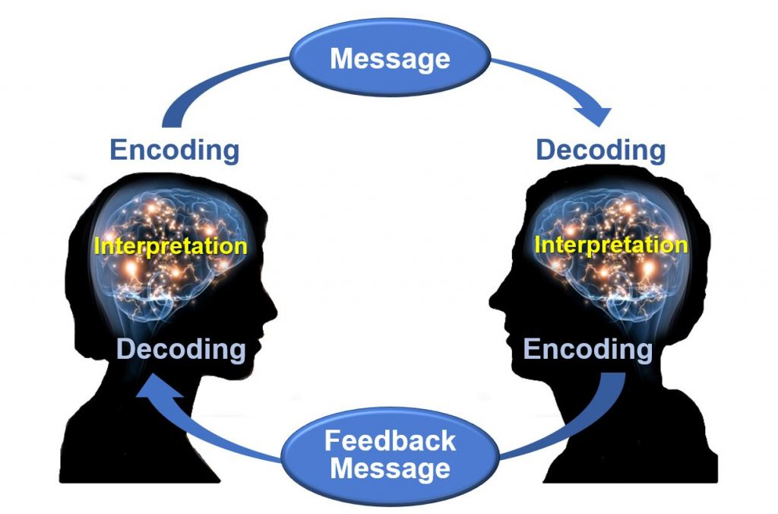

Nurses assist patients and their family members to understand health care needs and treatments by using verbal, nonverbal, and written communication. Verbal communication is more than just talking. Effective verbal communication is defined as an exchange of information using words understood by the receiver in a way that conveys professional caring and respect. Nurses who speak using extensive medical jargon or slang may create an unintended barrier to their own verbal communication processes. When communicating with others, it is important for the nurse to assess the receiver’s preferred method of communication and individual receiver characteristics that might influence communication, and subsequently adapt communication to meet the receiver’s needs. For example, the nurse may adapt postsurgical verbal instruction for a pediatric versus an adult patient. Although the information requirements regarding signs of infection, pain management, etc., might be similar, the way in which information is provided may be quite different based on developmental level. Regardless of the individual adaptations that are made, the nurse must be sure to always verify patient understanding.

Nonverbal Communication
In addition to communicating verbally, the nurse must also be aware of messages sent by nonverbal communication. Nonverbal communication can have a tremendous impact on the communication experience and may be much more powerful than the verbal message itself. You may have previously learned that 80% of communication is nonverbal communication (see Figure 2.2). The importance of nonverbal communication during communication has also been described in percentages of 55, 38, and 7, meaning 55% of communication is body language, 38% is tone of voice, and 7% is the actual words spoken.

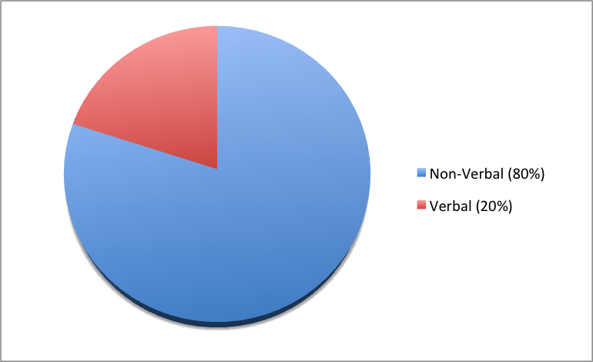

Nonverbal communication includes body language and facial expressions, tone of voice, and pace of the conversation. For example, compare the nonverbal communication messages in Figures 2.3 and 2.4.What nonverbal cues do you notice about both toddlers?





Nurses should be attentive to their nonverbal communication cues and the messages they provide to patients and their families. Nurses should be purposeful in their use of nonverbal communication that conveys a feeling of caring. What nonverbal cues do you notice about the nurse in Figure 2.5 that provide a perception of professional caring?

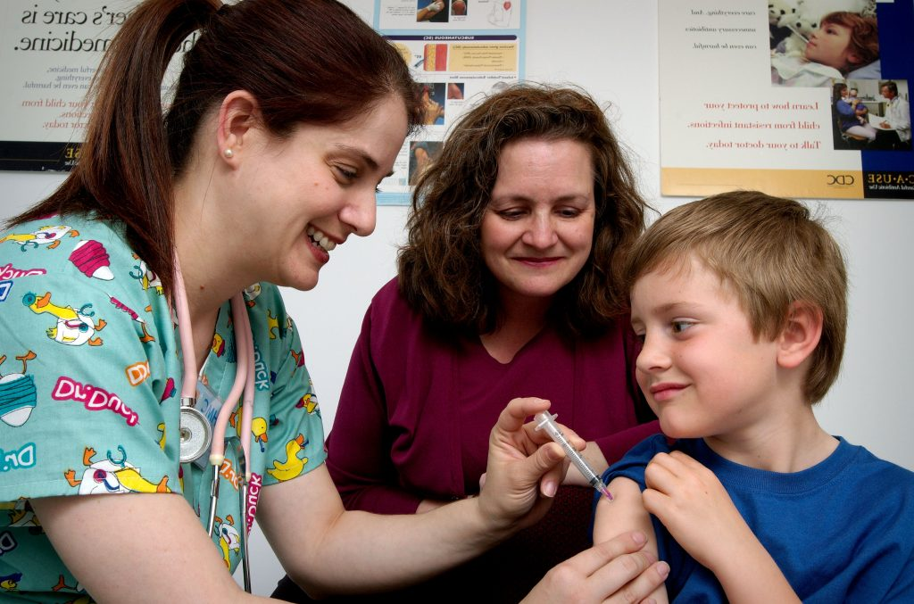

Nurses use nonverbal communication such as directly facing patients at eye level, leaning slightly forward, and making eye contact to communicate they care about what the person is telling them and they have their full attention.
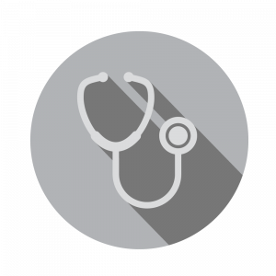
It is common for health care team members in an acute care setting to enter a patient’s room and begin interacting with a patient who is seated or lying in bed. However, it is important to remember that initial or sensitive communication exchanges are best received by the patient if the nurse and patient are at eye level. Bringing a chair to the patient’s bedside can help to facilitate engagement in the communication exchange. SOLER is common mnemonic used to facilitate nonverbal communication (sit with open posture and lean in with good eye contact in a relaxed manner).

Communication Styles
In addition to verbal and nonverbal communication, people communicate with others using three styles. A passive communicator puts the rights of others before their own. Passive communicators tend to be apologetic or sound tentative when they speak and often do not speak up if they feel as if they are being wronged. Aggressive communicators, on the other hand, come across as advocating for their own rights despite possibly violating the rights of others. They tend to communicate in a way that tells others their feelings don’t matter. However, assertive communicators respect the rights of others while also standing up for their own ideas and rights when communicating. An assertive person is direct, but not insulting or offensive. Assertive communication refers to a way of conveying information that describes the facts and the sender’s feelings without disrespecting the receiver’s feelings. Using “I” messages such as, “I feel…,” “I understand…,” or “Help me to understand…” are strategies for assertive communication. This method of communicating is different from aggressive communication that uses “you” messages and can feel as if the sender is verbally attacking the receiver rather than dealing with the issue at hand. For example, instead of saying to a coworker, “Why is it always so messy in your patients’ rooms? I dread following you on the next shift!,” an assertive communicator would use “I” messages to say, “I feel frustrated spending the first part of my shift decluttering our patients’ rooms. Help me understand why it is a challenge to keep things organized during your shift?”
Using assertive communication is an effective way to solve problems with patients, coworkers, and health care team members.
View this humorous video demonstrating assertive communication techniques being used by the actors on a TV show:
Everybody Loves Raymond Uses Active Listening – from Parent Effectiveness Training.

Personal Space
While being aware of verbal and nonverbal messages and communicating assertively, it is also important to be aware of others’ personal space. Proxemics is the study of personal space and provides guidelines for professional communication. The public zone is over 10 feet of distance between people and generally avoids physical contact. The social zone is four to 10 feet of distance between people. It is used during social interactions and business settings. The personal zone is 18 inches to four feet of space and is generally reserved for friends and family. Less than 18 inches is reserved for close relationships but may be invaded when in crowds or playing sports. Nurses usually communicate within the social zone to maintain professional boundaries. However, when assessing patients and performing procedures, nurses often move into a patient’s personal zone. Nurses must be aware of patients’ feelings of psychological discomfort that can occur when invading this zone. Additionally, cultural considerations may impact the appropriateness of personal space when providing patient care. See Figure 2.6 for example of personal space zones.

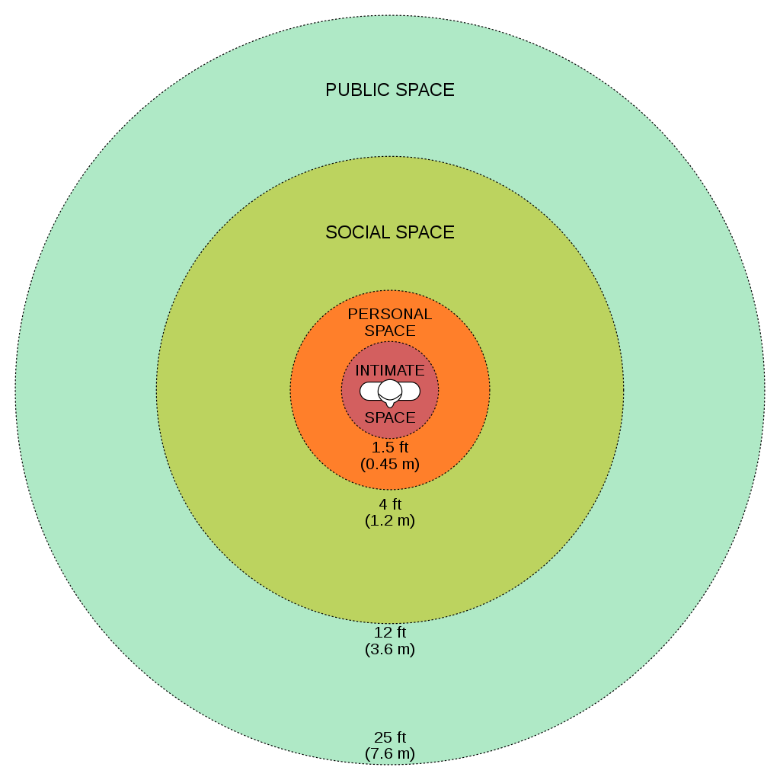

Overcoming Common Barriers to Communication
It is important for you to reflect on personal factors that influence your ability to communicate effectively. There are many factors that can cause the message you are trying to communicate to become distorted and not perceived by the receiver in the way you intended. It is important to seek feedback that your message is clearly understood. Nurses must be aware of these potential barriers and try to reduce their impact by continually seeking feedback and checking understanding.
Common barriers to communication in health care and strategies to overcome them are described in the following box.
Common Barriers to Communication in Health Care
- Jargon: Avoid using medical terminology, complicated, or unfamiliar words. When communicating with patients, explain information in plain language that is easy to understand by those without a medical or nursing background.
- Lack of attention: Nurses are typically very busy with several tasks to complete for multiple patients. It is easy to become focused on the tasks instead of the patient. When entering a patient’s room, it is helpful to pause, take a deep breath, and mindfully focus on the patient in front of you to give them your full attention. Patients should feel as if they are the center of your attention when you are with them, no matter how many other things you have going on.
- Noise and other distractions: Health care environments can be very noisy with people talking in the room or hallway, the TV blaring, alarms beeping, and pages occurring overhead. Create a calm, quiet environment when communicating with patients by closing doors to the hallway, reducing the volume of the TV, or moving to a quieter area, if possible.
- Light: A room that is too dark or too light can create communication barriers. Ensure the lighting is appropriate according to the patient’s preference.
- Hearing and speech problems: If your patient has hearing or speech problems, implement strategies to enhance communication. See the “Adapting Your Communication” section below for strategies to address hearing and speech problems.
- Language differences: If English is not your patient’s primary language, it is important to seek a medical interpreter and to also provide written handouts in the patient’s preferred language when possible. Most agencies have access to an interpreter service available by phone if they are not available on-site.
- Differences in cultural beliefs: The norms of social interaction vary greatly in different cultures, as well as the ways that emotions are expressed. For example, the concept of personal space varies among cultures, and some patients are stoic about pain whereas others are more verbally expressive. Read more about caring for diverse patients in the “Diversity” chapter.
- Psychological barriers: Psychological states of the sender and the receiver affect how the message is sent, received, and perceived. For example, if nurses are feeling stressed and overwhelmed with required tasks, the nonverbal communication associated with their messages such as lack of eye contact, a hurried pace, or a short tone can affect how the patient perceives the message. If a patient is feeling stressed, they may not be able to “hear” the message or they may perceive it differently than it was intended. It is important to be aware of signs of the stress response in ourselves and our patients and implement appropriate strategies to manage the stress response. See the box below for more information about strategies to manage the stress response.
- Physiological barriers: It is important to be aware of patients’ potential physiological barriers when communicating. For example, if a patient is in pain, they are less likely to hear and remember what was said, so pain relief should be provided as needed before providing patient education. However, it is also important to remember that sedatives and certain types of pain medications often impair the patient’s ability to receive and perceive messages so health care documents cannot be signed by a patient after receiving these types of medications.
- Physical barriers for nonverbal communication: Providing information via e-mail or text is often less effective than face-to-face communication. The inability to view the nonverbal communication associated with a message such as tone of voice, facial expressions, and general body language often causes misinterpretation of the message by the receiver. When possible, it is best to deliver important information to others using face-to-face communication so that nonverbal communication is included with the message.
- Differences in perception and viewpoints: Everyone has their own beliefs and perspectives and wants to feel “heard.” When patients feel their beliefs or perspectives are not valued, they often become disengaged from the conversation or the plan of care. Nurses should provide health care information in a nonjudgmental manner, even if the patient’s perspectives, viewpoints, and beliefs are different from their own.

Managing the Stress Response
The stress response is a common psychological barrier to effective communication. It can affect the message sent by the sender or how it is received by the receiver. The stress response is a common reaction to life events, such as a nurse feeling stressed by being overwhelmed with tasks to complete for multiple patients, or a patient feeling stressed when admitted to a hospital or receiving a new diagnosis. Symptoms of the stress response include irritability, sweaty palms, a racing heart, difficulty concentrating, and impaired sleep. It is important to recognize symptoms of the stress response in ourselves and our patients and use strategies to manage the stress response when communicating. Strategies to manage the stress response are as follows:
- Use relaxation breathing. Become aware of your breathing. Take a deep breath in your nose and blow it out through your mouth. Repeat this process at least three times in succession and then as often as needed throughout the day.
- Make healthy diet choices. Avoid caffeine, nicotine, and junk food because these items can increase feelings of anxiety or being on edge.
- Make time for exercise. Exercise stimulates the release of natural endorphins that reduce the body’s stress response and also helps to improve sleep.
- Get enough sleep. Set aside at least 30 minutes before going to bed to wind down from the busyness of the day. Avoid using electronic devices like cell phones before bedtime because the backlight can affect sleep.
- Use progressive relaxation. There are several types of relaxation techniques that focus on reducing muscle tension and using mental imagery to induce calmness. Progressive relaxation generally includes the following steps:
  - Start by lying down somewhere comfortable and firm, like a rug or mat on the floor. Get yourself comfortable.
  - Relax and try to let your mind go blank. Breathe slowly, deeply, and comfortably, while gradually and consciously relaxing all your muscles, one by one.
  - Work around the body one main muscle area at a time, breathing deeply, calmly, and evenly. For each muscle group, clench the muscles tightly and hold for a few seconds, and then relax them completely. Repeat the process, noticing how it feels. Do this for each of your feet, calves, thighs, buttocks, stomach, arms, hands, shoulders, and face.

American Nurses Association. (2015).
(3rd ed.). American Nurses Association.

“Osgood-Schramm-model-of-communication.jpg“ by Jordan Smith at eCampus Ontario is licensed under
. Access for free at

This work is a derivative of
by
and is licensed under

“
” by
is licensed under

Thompson, J. (2011). Is nonverbal communication a numbers game?

“
” by
is licensed under

“
” by
is licensed under

This work is a derivative of
by
and is licensed under

"
" by James Gathany, Judy Schmidt, USCDCP is in the

Stickley, T. (2011). From SOLER to SURETY for effective non-verbal communication.
(6), 395-398.

This work is a derivative of
by
and is licensed under

Psychology Today. (n.d.) Proxemics.

“
” by
is licensed under

SkillsYouNeed. (n.d.).
.

SkillsYouNeed. (n.d.).
.

American Psychological Association. (2019). Healthy Ways to Handle Life's Stressors.

2.3 Communicating with Patients
Open Resources for Nursing (Open RN)
Therapeutic communication is a type of professional communication used by nurses with patients and defined as, “The purposeful, interpersonal information-transmitting process through words and behaviors based on both parties’ knowledge, attitudes, and skills, which leads to patient understanding and participation.” Therapeutic communication techniques used by nurses have roots going back to Florence Nightingale, who insisted on the importance of building trusting relationships with patients and believed in the therapeutic healing that resulted from nurses’ presence with patients. Since then, several professional nursing associations have highlighted therapeutic communication as one of the most vital elements in nursing.
Read an example of a nursing student effectively using therapeutic communication with patients in the following box.
An Example of Nursing Student Using Therapeutic Communication



Ms. Z. is a nursing student who enjoys interacting with patients. When she goes to patients’ rooms, she greets them and introduces herself and her role in a calm tone. She kindly asks patients about their problems and notices their reactions. She does her best to solve their problems and answer their questions. Patients perceive that she wants to help them. She treats patients professionally by respecting boundaries and listening to them in a nonjudgmental manner. She addresses communication barriers and respects patients’ cultural beliefs. She notices patients’ health literacy and ensures they understand her messages and patient education. As a result, patients trust her and feel as if she cares about them, so they feel comfortable sharing their health care needs with her.,

Active Listening and Attending Behaviors
Listening is obviously an important part of communication. There are three main types of listening: competitive, passive, and active. Competitive listening happens when we are focused on sharing our own point of view instead of listening to someone else. Passive listening occurs when we are not interested in listening to the other person and we assume we understand what the person is communicating correctly without verifying. During active listening, we are communicating verbally and nonverbally that we are interested in what the other person is saying while also actively verifying our understanding with the speaker. For example, an active listening technique is to restate what the person said and then verify our understanding is correct. This feedback process is the main difference between passive listening and active listening.

Touch
Touch is a powerful way to professionally communicate caring and empathy if done respectfully while being aware of the patient’s cultural beliefs. Nurses commonly use professional touch when assessing, expressing concern, or comforting patients. For example, simply holding a patient’s hand during a painful procedure can be very effective in providing comfort. See Figure 2.7 for an image of a nurse using touch as a therapeutic technique when caring for a patient.

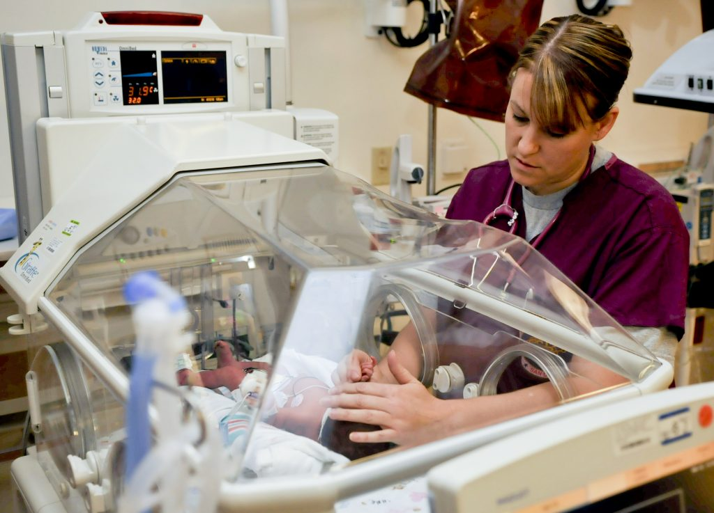

Therapeutic Techniques
Therapeutic communication techniques are specific methods used to provide patients with support and information while focusing on their concerns. Nurses assist patients to set goals and select strategies for their plan of care based on their needs, values, skills, and abilities. It is important to recognize the autonomy of the patient to make their own decisions, maintain a nonjudgmental attitude, and avoid interrupting. Depending on the developmental stage and educational needs of the patient, appropriate terminology should be used to promote patient understanding and rapport. When using therapeutic communication, nurses often ask open-ended statements and questions, repeat information, or use silence to prompt patients to work through problems on their own. Table 2.3a describes a variety of therapeutic communication techniques.
Table 2.3a Therapeutic Communication Techniques
Therapeutic Technique | Description
Active Listening | By using nonverbal and verbal cues such as nodding and saying “I see,” nurses can encourage patients to continue talking. Active listening involves showing interest in what patients have to say, acknowledging that you’re listening and understanding, and engaging with them throughout the conversation. Nurses can offer general leads such as “What happened next?” to guide the conversation or propel it forward.
Using Silence | At times, it’s useful to not speak at all. Deliberate silence can give both nurses and patients an opportunity to think through and process what comes next in the conversation. It may give patients the time and space they need to broach a new topic.
Accepting | Sometimes it is important to acknowledge a patient’s message and affirm that they’ve been heard. Acceptance isn’t necessarily the same thing as agreement; it can be enough to simply make eye contact and say, “Yes, I hear what you are saying.” Patients who feel their nurses are listening to them and taking them seriously are more likely to be receptive to care.
Giving Recognition | Recognition acknowledges a patient’s behavior and highlights it. For example, saying something such as “I noticed you took all of your medications today” draws attention to the action and encourages it.
Offering Self | Hospital stays can be lonely and stressful at times. When nurses are present with their patients, it shows patients they value them and are willing to give them time and attention. Offering to simply sit with patients for a few minutes is a powerful way to create a caring connection.
Giving Broad Openings/Open-Ended Questions | Therapeutic communication is often most effective when patients direct the flow of conversation and decide what to talk about. To that end, giving patients a broad opening such as “What’s on your mind today?” or “What would you like to talk about?” can be a good way to allow patients an opportunity to discuss what’s on their mind.
Seeking Clarification | Similar to active listening, asking patients for clarification when they say something confusing or ambiguous is important. Saying something such as “I’m not sure I understand. Can you explain it to me?” helps nurses ensure they understand what’s actually being said and can help patients process their ideas more thoroughly.
Placing the Event in Time or Sequence | Asking questions about when certain events occurred in relation to other events can help patients (and nurses) get a clearer sense of the whole picture. It forces patients to think about the sequence of events and may prompt them to remember something they otherwise wouldn’t.
Making Observations | Observations about the appearance, demeanor, or behavior of patients can help draw attention to areas that may indicate a problem. Observing that they look tired may prompt patients to explain why they haven’t been getting much sleep lately, or making an observation that they haven’t been eating much may lead to the discovery of a new symptom.
Encouraging Descriptions of Perception | For patients experiencing sensory issues or hallucinations, it can be helpful to ask about these perceptions in an encouraging, nonjudgmental way. Phrases such as “What do you hear now?” or “What does that look like to you?” give patients a prompt to explain what they’re perceiving without casting their perceptions in a negative light.
Encouraging Comparisons | Patients often draw upon previous experiences to deal with current problems. By encouraging them to make comparisons to situations they have coped with before, nurses can help patients discover solutions to their problems.
Summarizing | It is often useful to summarize what patients have said. This demonstrates to patients that the nurse was listening and allows the nurse to verify information. Ending a summary with a phrase such as “Does that sound correct?” gives patients explicit permission to make corrections if they’re necessary.
Reflecting | Patients often ask nurses for advice about what they should do about particular problems. Nurses can ask patients what they think they should do, which encourages them to be accountable for their own actions and helps them come up with solutions themselves.
Focusing | Sometimes during a conversation, patients mention something particularly important. When this happens, nurses can focus on their statement, prompting patients to discuss it further. Patients don’t always have an objective perspective on what is relevant to their case, but as impartial observers, nurses can more easily pick out the topics on which to focus.
Confronting | Nurses should only apply this technique after they have established trust. In some situations, it can be vital to the care of patients to disagree with them, present them with reality, or challenge their assumptions. Confrontation, when used correctly, can help patients break destructive routines or understand the state of their current situation.
Voicing Doubt | Voicing doubt can be a gentler way to call attention to incorrect or delusional ideas and perceptions of patients. By expressing doubt, nurses can force patients to examine their assumptions.
Offering Hope and Humor | Because hospitals can be stressful places for patients, sharing hope that they can persevere through their current situation and lightening the mood with humor can help nurses establish rapport quickly. This technique can keep patients in a more positive state of mind. However, it is important to tailor humor to the patient’s sense of humor.
In addition to the therapeutic techniques listed in Table 2.3a, nurses and nursing students should genuinely communicate with empathy. Communicating honestly, genuinely, and authentically is powerful. It opens the door to creating true connections with others. Communicating with empathy has also been described as providing “unconditional positive regard.” Research has demonstrated that when health care teams communicate with empathy, there is improved patient healing, reduced symptoms of depression, and decreased medical errors.
Nurses and nursing students must be aware of potential barriers to communication. In addition to considering common communication barriers discussed in the previous section, there are several nontherapeutic responsesto avoid. These responses often block the patient’s communication of their feelings or ideas. See Table 2.3b for a description of nontherapeutic responses.
Table 2.3b Nontherapeutic Responses
Nontherapeutic Response | Description
Asking Personal Questions | Asking personal questions that are not relevant to the situation is not professional or appropriate. Don’t ask questions just to satisfy your curiosity. For example, asking, “Why have you and Mary never married?” is not appropriate. A more therapeutic question would be, “How would you describe your relationship with Mary?”
Giving Personal Opinions | Giving personal opinions takes away the decision-making from the patient. Effective problem-solving must be accomplished by the patient and not the nurse. For example, stating, “If I were you, I’d put your father in a nursing home” is not therapeutic. Instead, it is more therapeutic to say, “Let’s talk about what options are available to your father.”
Changing the Subject | Changing the subject when someone is trying to communicate with you demonstrates lack of empathy and blocks further communication. It seems to say that you don’t care about what they are sharing. For example, stating, “Let’s not talk about your insurance problems; it’s time for your walk now” is not therapeutic. A more therapeutic response would be, “After your walk, let’s talk some more about what’s going on with your insurance company.”
Stating Generalizations and Stereotypes | Generalizations and stereotypes can threaten nurse-patient relationships. For example, it is not therapeutic to state the stereotype, “Older adults are always confused.” It is better to focus on the patient’s concern and ask, “Tell me more about your concerns about your father’s confusion.”
Providing False Reassurances | When a patient is seriously ill or distressed, the nurse may be tempted to offer hope with statements such as “You’ll be fine,” or “Don’t worry; everything will be alright.” These comments tend to discourage further expressions of feelings by the patient. A more therapeutic response would be, “It must be difficult not to know what the surgeon will find. What can I do to help?”
Showing Sympathy | Sympathy focuses on the nurse’s feelings rather than the patient. Saying “I’m so sorry about your amputation; I can’t imagine losing a leg.” This statement shows pity rather than trying to help the patient cope with the situation. A more therapeutic response would be, “The loss of your leg is a major change; how do you think this will affect your life?”
Asking “Why” Questions | A nurse may be tempted to ask the patient to explain “why” they believe, feel, or act in a certain way. However, patients and family members interpret “why” questions as accusations and become defensive. It is best to phrase a question by avoiding the word “why.” For example, instead of asking, “Why are you so upset?” it is better to rephrase the statement as, “You seem upset. What’s on your mind?”
Approving or Disapproving | Nurses should not impose their own attitudes, values, beliefs, and moral standards on others while in the professional nursing role. Judgmental messages contain terms such as “should,” “shouldn’t,” “ought to,” “good,” “bad,” “right,” or “wrong.” Agreeing or disagreeing sends the subtle message that nurses have the right to make value judgments about the patient’s decisions. Approving implies that the behavior being praised is the only acceptable one, and disapproving implies that the patient must meet the nurse’s expectations or standards. Instead, the nurse should help the patient explore their own beliefs and decisions. For example, it is nontherapeutic to state, “You shouldn’t consider elective surgery; there are too many risks involved.” A more therapeutic response would be, “So you are considering elective surgery. Tell me more about it…” gives the patient a chance to express their ideas or feelings without fear of being judged.
Giving Defensive Responses | When patients or family members express criticism, nurses should listen to what they are saying. Listening does not imply agreement. To discover reasons for the patient’s anger or dissatisfaction, the nurse should listen without criticism, avoid being defensive or accusatory, and attempt to defuse anger. For example, it is not therapeutic to state, “No one here would intentionally lie to you.” Instead, a more therapeutic response would be, “You believe people have been dishonest with you. Tell me more about what happened.” (After obtaining additional information, the nurse may elect to follow the chain of command at the agency and report the patient’s concerns for follow-up.)
Providing Passive or Aggressive Responses | Basic Communication Concepts
Arguing | Challenging or arguing against patient perceptions denies that they are real and valid to the other person. They imply that the other person is lying, misinformed, or uneducated. The skillful nurse can provide information or present reality in a way that avoids argument. For example, it is not therapeutic to state, “How can you say you didn’t sleep a wink when I heard you snoring all night long!” A more therapeutic response would be, “You don’t feel rested this morning? Let’s talk about ways to improve your rest.”

Strategies for Effective Communication
In addition to using therapeutic communication techniques, avoiding nontherapeutic responses, and overcoming common barriers to communication, there are additional strategies for promoting effective communication when providing patient-centered care. Specific questions to ask patients are as follows:
- What concerns do you have about your plan of care?
- What questions do you have about your medications?
- Did I answer your question(s) clearly or is there additional information you would like?
Listen closely for feedback from patients. Feedback provides an opportunity to improve patient understanding, improve the patient-care experience, and provide high-quality care. Other suggestions for effective communication with hospitalized patients include the following:
- Round with the providers and read progress notes from other health care team members to ensure you have the most up-to-date information about the patient’s treatment plan and progress. This information helps you to provide safe patient care as changes occur and also to accurately answer the patient’s questions.
- Review information periodically with the patient to improve understanding.
- Use patient communication boards in their room to set goals and communicate important reminders with the patient, family members, and other health care team members. This strategy can reduce call light usage for questions related to diet and activity orders and also gives patients and families the feeling that they always know the current plan of care. However, keep patient confidentiality in mind regarding information to publicly share on the board that visitors may see.
- Provide printed information on medical procedures, conditions, and medications. It helps patients and family members to have multiple ways to provide information.

Adapting Your Communication
When communicating with patients and family members, take note of your audience and adapt your message based on their characteristics such as age, developmental level, cognitive abilities, and any communication disorders. For patients with language differences, it is vital to provide trained medical interpreters when important information is communicated.
Adapting communication according to the patient’s age and developmental level includes the following strategies:
- When communicating with children, speak calmly and gently. It is often helpful to demonstrate what will be done during a procedure on a doll or stuffed animal. To establish trust, try using play or drawing pictures.
- When communicating with adolescents, give freedom to make choices within established limits.
- When communicating with older adults, be aware of potential vision and hearing impairments that commonly occur and address these barriers accordingly. For example, if a patient has glasses and/or hearing aids, be sure these devices are in place before communicating. See the following box for evidence-based strategies for communication with patients who have impaired hearing and vision.
Strategies for Communicating with Patients with Impaired Hearing and Vision
Impaired Hearing
- Gain the patient’s attention before speaking (e.g., through touch)
- Minimize background noise
- Position yourself 2-3 feet away from the patient
- Facilitate lip-reading by facing the patient directly in a well-lit environment
- Use gestures, when necessary
- Listen attentively, allowing the patient adequate time to process communication and respond
- Refrain from shouting at the patient
- Ask the patient to suggest strategies for improved communication (e.g., speaking toward better ear and moving to well-lit area)
- Face the patient directly, establish eye contact, and avoid turning away mid sentence
- Simplify language (i.e., do not use slang but do use short, simple sentences), as appropriate
- Note and document the patient’s preferred method of communication (e.g., verbal, written, lip-reading, or American Sign Language) in plan of care
- Assist the patient in acquiring a hearing aid or assistive listening device
- Refer to the primary care provider or specialist for evaluation, treatment, and hearing rehabilitation
Impaired Vision
- Identify yourself when entering the patient’s space
- Ensure the patient’s eyeglasses or contact lenses have current prescription, are cleaned, and stored properly when not in use
- Provide adequate room lighting
- Minimize glare (i.e., offer sunglasses or draw window covering)
- Provide educational materials in large print
- Apply labels to frequently used items (i.e., mark medication bottles using high-contrasting colors)
- Read pertinent information to the patient
- Provide magnifying devices
- Provide referral for supportive services (e.g., social, occupational, and psychological)
Patients with communication disorders require additional strategies to ensure effective communication. For example, aphasia is a communication disorder that results from damage to portions of the brain that are responsible for language. Aphasiausually occurs suddenly, often following a stroke or head injury, and impairs the patient’s expression and understanding of language. Global aphasia is caused by injuries to multiple language-processing areas of the brain, including those known as Wernicke’s and Broca’s areas. These brain areas are particularly important for understanding spoken language, accessing vocabulary, using grammar, and producing words and sentences. Individuals with global aphasia may be unable to say even a few words or may repeat the same words or phrases over and over again. They may have trouble understanding even simple words and sentences.
The most common type of aphasia is Broca's aphasia. People with Broca’s aphasia often understand speech and know what they want to say, but frequently speak in short phrases that are produced with great effort. For example, they may intend to say, “I would like to go to the bathroom,” but instead the words, “Bathroom, Go,” are expressed. They are often aware of their difficulties and can become easily frustrated. See the hyperlink in the box below for evidence-based strategies to enhance communication with a person with impaired speech.

Strategies to Improve Communication with Patients with Impaired Speech
- Modify the environment to minimize excess noise and decrease emotional distress
- Phrase questions so the patient can answer using a simple “Yes” or “No,” being aware that patients with expressive aphasia may provide automatic responses that are incorrect
- Monitor the patient for frustration, anger, depression, or other responses to impaired speech capabilities
- Provide alternative methods of speech communication (e.g., writing tablet, flash cards, eye blinking, communication board with pictures and letters, hand signals or gestures, and computer)
- Adjust your communication style to meet the needs of the patient (e.g., stand in front of the patient while speaking, listen attentively, present one idea or thought at a time, speak slowly but avoid shouting, use written communication, or solicit family’s assistance in understanding the patient’s speech)
- Ensure the call light is within reach and central call light system is marked to indicate the patient has difficulty with speech
- Repeat what the patient said to ensure accuracy
- Instruct the patient to speak slowly
- Collaborate with the family and a speech therapist to develop a plan for effective communication

Maintaining Patient Confidentiality
When communicating with patients, their friends, their family members, and other members of the health care team, it is vital for the nurse to maintain patient confidentiality. The Health Insurance Portability and Accountability Act (HIPAA) provides standards for ensuring privacy of patient information that are enforceable by law. Nurses must always be aware of where and with whom they share patient information. For example, information related to patient care should not be discussed in public areas, paper charts must be kept in secure areas, computers must be logged off when walked away from, and patient information should only be shared with those directly involved in patient care. For more information about patient confidentiality, see the “Legal Considerations Ethics” section in the “Scope of Practice” chapter.
Read more information about the Health Insurance Portability and Accountability Act of 1996 (HIPAA).

Abdolrahimi, M., Ghiyasvandian, S., Zakerimoghadam, M., Ebadi, A. (2017). Therapeutic communication in nursing students: A Walker Avant concept analysis.
(8), 4968–4977.

Karimi, H., Masoudi Alavi, N. (2015). Florence Nightingale: The mother of nursing.
(2), e29475.
.

Abdolrahimi, M., Ghiyasvandian, S., Zakerimoghadam, M., Ebadi, A. (2017). Therapeutic communication in nursing students: A Walker Avant concept analysis.
(8), 4968–4977.

“
” by
is in the

This work is a derivative of
by
and is licensed under

” by MC2 John O'Neill Herrera/
is in the

American Nurse. (n.d.).
.

American Nurse. (n.d.).
.

Balchan, M. (2016). The Magic of Genuine Communication.

Morrison, E. (2019). Empathetic Communication in Healthcare.

Burke, A. (2021). Therapeutic Communication: NCLEX-RN.

Smith, L. L. (2018, June 12). Strategies for effective patient communication.
.

Smith, L. L. (2018, June 12). Strategies for effective patient communication.

Butcher, H., Bulechek, G., Dochterman, J., Wagner, C. (2018).
. Elsevier, pp. 115-116

Butcher, H., Bulechek, G., Dochterman, J., Wagner, C. (2018
. Elsevier, pp. 115-116

Butcher, H., Bulechek, G., Dochterman, J., Wagner, C. (2018).
. Elsevier, pp. 115-116

National Institute on Deafness and Other Communication Disorders (NIDCD). (2017, March 6). Aphasia.

Butcher, H., Bulechek, G., Dochterman, J., Wagner, C. (2018).
. Elsevier, pp. 115-116.

Butcher, H., Bulechek, G., Dochterman, J., Wagner, C. (2018).
Elsevier, pp. 115-116.

2.4 Communicating with Health Care Team Members
Open Resources for Nursing (Open RN)
Professional communication with other members of the health care team is an important component of every nurse’s job. See Figure 2.8 for an image illustrating communication between health care team members. Common types of professional interactions include reports to health care team members, handoff reports, and transfer reports.



Reports to Health Care Team Members
Nurses routinely report information to other health care team members, as well as urgently contact health care providers to report changes in patient status.
Standardized methods of communication have been developed to ensure that information is exchanged between health care team members in a structured, concise, and accurate manner to ensure safe patient care. One common format used by health care team members to exchange patient information is ISBARR, a mnemonic for the components of Introduction, Situation, Background, Assessment, Request/Recommendations, and Repeat back.

  - Introduction: Introduce your name, role, and the agency from which you are calling.
  - Situation: Provide the patient’s name and location, why you are calling, recent vital signs, and the status of the patient.
  - Background: Provide pertinent background information about the patient such as admitting medical diagnoses, code status, recent relevant lab or diagnostic results, and allergies.
  - Assessment: Share abnormal assessment findings and your evaluation of the current patient situation.
  - Request/Recommendations: State what you would like the provider to do, such as reassess the patient, order a lab/diagnostic test, prescribe/change medication, etc.
  - Repeat back: If you are receiving new orders from a provider, repeat them to confirm accuracy. Be sure to document communication with the provider in the patient’s chart.
Read an example of an ISBARR report in the following box. A hyperlink is provided to a printable ISBARR reference card.
Sample ISBARR Report From a Nurse to a Health Care Provider
I: “Hello Dr. Smith, this is Jane White, RN from the Med Surg unit.”
S: “I am calling to tell you about Ms. White in Room 210, who is experiencing an increase in pain, as well as redness at her incision site. Her recent vital signs were BP 160/95, heart rate 90, respiratory rate 22, O2 sat 96%, and temperature 38 degrees Celsius. She is stable but her pain is worsening.”
B: “Ms. White is a 65-year-old female, admitted yesterday post hip surgical replacement. She has been rating her pain at 3 or 4 out of 10 since surgery with her scheduled medication, but now she is rating the pain as a 7, with no relief from her scheduled medication of Vicodin 5/325 mg administered an hour ago. She is scheduled for physical therapy later this morning and is stating she won’t be able to participate because of the pain this morning.”
A: “I just assessed the surgical site and her dressing was clean, dry, and intact, but there is 4 cm redness surrounding the incision, and it is warm and tender to the touch. There is moderate serosanguinous drainage. Otherwise, her lungs are clear and her heart rate is regular.”
R: “I am calling to request an order for a CBC and increased dose of pain medication.”
R: “I am repeating back the order to confirm that you are ordering a STAT CBC and an increase of her Vicodin to 10/325 mg.”
View or print an ISBARR reference card
.

Handoff Reports
Handoff reportsare defined by The Joint Commission as “a transfer and acceptance of patient care responsibility achieved through effective communication. It is a real-time process of passing patient specific information from one caregiver to another, or from one team of caregivers to another, for the purpose of ensuring the continuity and safety of the patient’s care.” In 2017, The Joint Commission issued a sentinel alert about inadequate handoff communication that has resulted in patient harm such as wrong-site surgeries, delays in treatment, falls, and medication errors. Strategies for improving handoff communication have been implemented at agencies across the country.
Although many types of nursing shift-to-shift handoff reports have been used over the years, evidence strongly supports that bedside handoff reports increase patient safety, as well as patient and nurse satisfaction, by effectively communicating current, accurate patient information in real time. See Figure 2.9 for an image illustrating two nurses participating in a handoff report. Bedside reports typically occur in hospitals and include the patient, along with the off-going and the oncoming nurses in a face-to-face handoff report conducted at the patient’s bedside. HIPAA rules must be kept in mind if visitors are present or the room is not a private room. Family members may be included with the patient’s permission. See a sample checklist for a bedside handoff report from the Agency for Healthcare Research and Quality in Figure 2.10. Although a bedside handoff report is similar to an ISBARR report, it contains additional information to ensure continuity of care across nursing shifts. For example, the “assessment” portion of the bedside handoff report includes detailed pertinent data the oncoming nurse needs to know, such as current head-to-toe assessment findings to establish a baseline; information about equipment such as IVs, catheters, and drainage tubes; and recent changes in medications, lab results, diagnostic tests, and treatments.



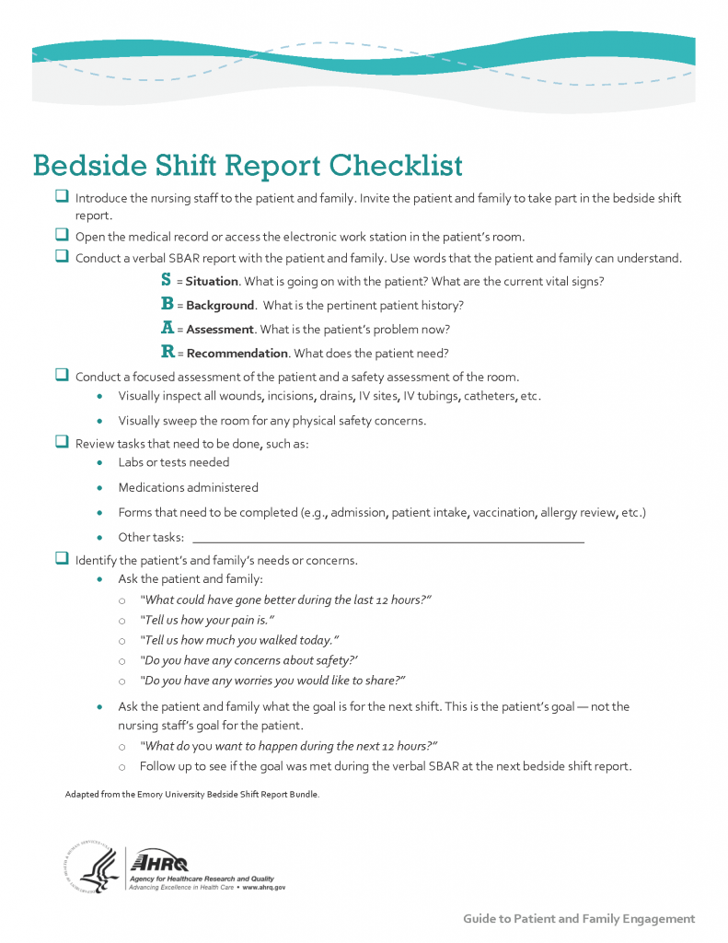

View a video on creating shift reports.

One or more interactive elements has been excluded from this version of the text. You can view them online here: https://wtcs.pressbooks.pub/nursingfundamentals/?p=313#oembed-1

Transfer Reports
Transfer reports are provided by nurses when transferring a patient to another unit or to another agency. Transfer reports contain similar information as bedside handoff reports, but are even more detailed when the patient is being transferred to another agency. Checklists are often provided by agencies to ensure accurate, complete information is shared.

"
" by
is used under license from

The Joint Commission. (n.d.).
.

Dorvil, B. (2018). The secrets to successful nurse bedside shift report implementation and sustainability.
(6), 20-25.

"
" by
is used under license from
.

"
" by
is licensed under

RegisteredNurseRN. (2015, May 23).
. [Video]. YouTube. All rights reserved. Video used with permission.

